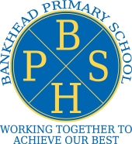

Keeping Bankhead Safe

Symptoms of COVID:
- New continuous cough
- Fever/high temperature
- Loss of or change in sense of taste or smell

Please do not send your child to school if they have any of the above symptoms or are unwell. If any member of your family has symptoms all members should stay at home and a covid test should be booked.

All siblings should stay at home and not be sent to school until a negative test has been received or they have self-isolated for the appropriate time.
Testing can be booked here: https://www.gov.uk/guidance/coronavirus-covid-19-getting-tested#who-can-be-tested

Please contact the school as soon as possible should you or anyone in your family be tested positive for coronavirus.

Please follow the test and protect guidance, book a test and self-isolate

Please continue to keep updated through the NHS inform website for the most up to date guidance:

https://www.nhsinform.scot/illnesses-and-conditions/infections-and-poisoning/coronavirus-covid-19

