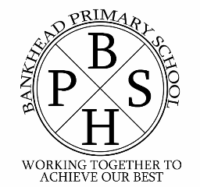
Bankhead Primary School’s Protocol for Pupils, Parents and Teachers in the Provision of Digital Learning as part of Remote Learning

Protocol for online classes

Teachers will:

- discuss roles and responsibilities with pupils at the outset of delivery
- be punctual at the beginning and end of each lesson
- notify all pupils/parents and schools of any cancelled classes or change in arrangements
- ensure that they keep themselves up to date with all relevant policies and procedures, including Child Protection
- prevent a one to one situation at the end of a class by disconnecting all participants from the room at the close of the lesson.

Pupils will:

- be punctual for all lessons
- access the files for each lesson in advance and have the materials to hand
- show respect for everyone in the online classroom
- dress appropriately for all classes, thinking about modesty and respect for others
- ensure the location they log in from is appropriate, i.e give consideration to background, camera angle, privacy etc.
- seek to contribute to the class in a positive manner and not be disruptive at any time
- not share recordings/images of the class outwith the class environment

Parents should;
• encourage their children to talk about and share their learning at home;
• not get involved in any live sessions, but please talk to your child about them afterwards and encourage them to take part;
• use existing methods of communicating with the school, if there are questions or concerns contact the school office.
At times, staff may choose to respond to messages, approve work, etc. outwith normal working hours. However, this should not be expected. Parents should not contact staff by e-mail through the Goggle Classroom stream. You can also contact the school by phone or email Mrs McKinlay at headteacher@bankhead-pri.glasgow.sch.uk Engagement with online learning will be monitored by the school on a weekly basis and support provided by the school.

