The Outbreak of War in Europe

Reading Comprehension Activity

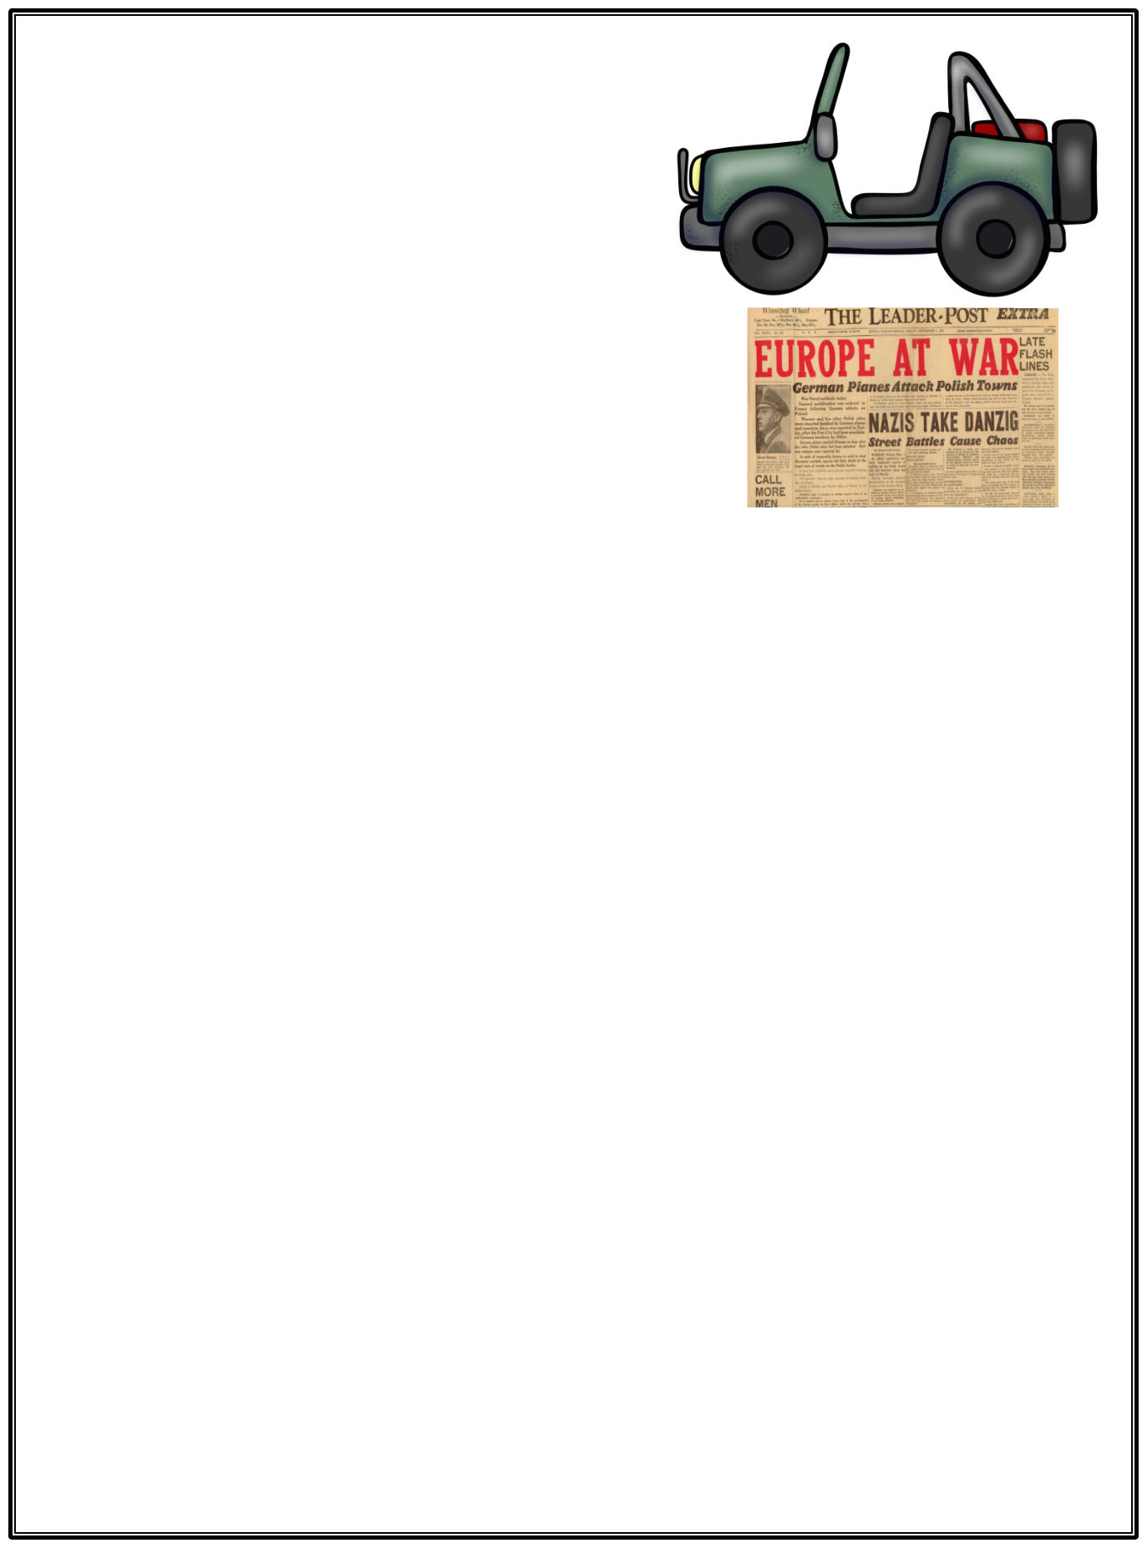
The Outbreak of War in Europe - 1939

The Declaration of war by France and the United Kingdom was given on the 3^{rd of} September 1939, after German forces invaded Poland. Despite the speech being the official announcement of both France and the United Kingdom, the speech was given by the British Prime Minister Neville Chamberlain, in Westminster, London.

At 11.15, the Prime Minister, Neville Chamberlain, delivered his broadcast from the Cabinet Room of 10 Downing Street, struggling to keep the anguish from his voice. “This morning, the British Ambassador in Berlin handed the German government a final note, stating that unless we heard from them – by 11 o'clock – that they were prepared at once to withdraw their troops from Poland, a state of war would exist between us”. Then came the words most feared by all. “I have to tell you now that no such undertaking has been received and that, consequently, this country is at war with Germany.”

The German invasion had initially begun on 1st September 1939, one week after the signing of the Molotov–Ribbentrop Pact, a treaty of non-aggression that vowed that neither the Soviet Union or Germany would attack each other. The campaign in Poland ended quickly, with the German army using the ‘blitzkrieg’ (or lightning war) tactic for the first time.

The greatest and most destructive war in history had begun. The world would change utterly – all foretold in that grave announcement on a calm Sunday morning in London almost 80 years ago.

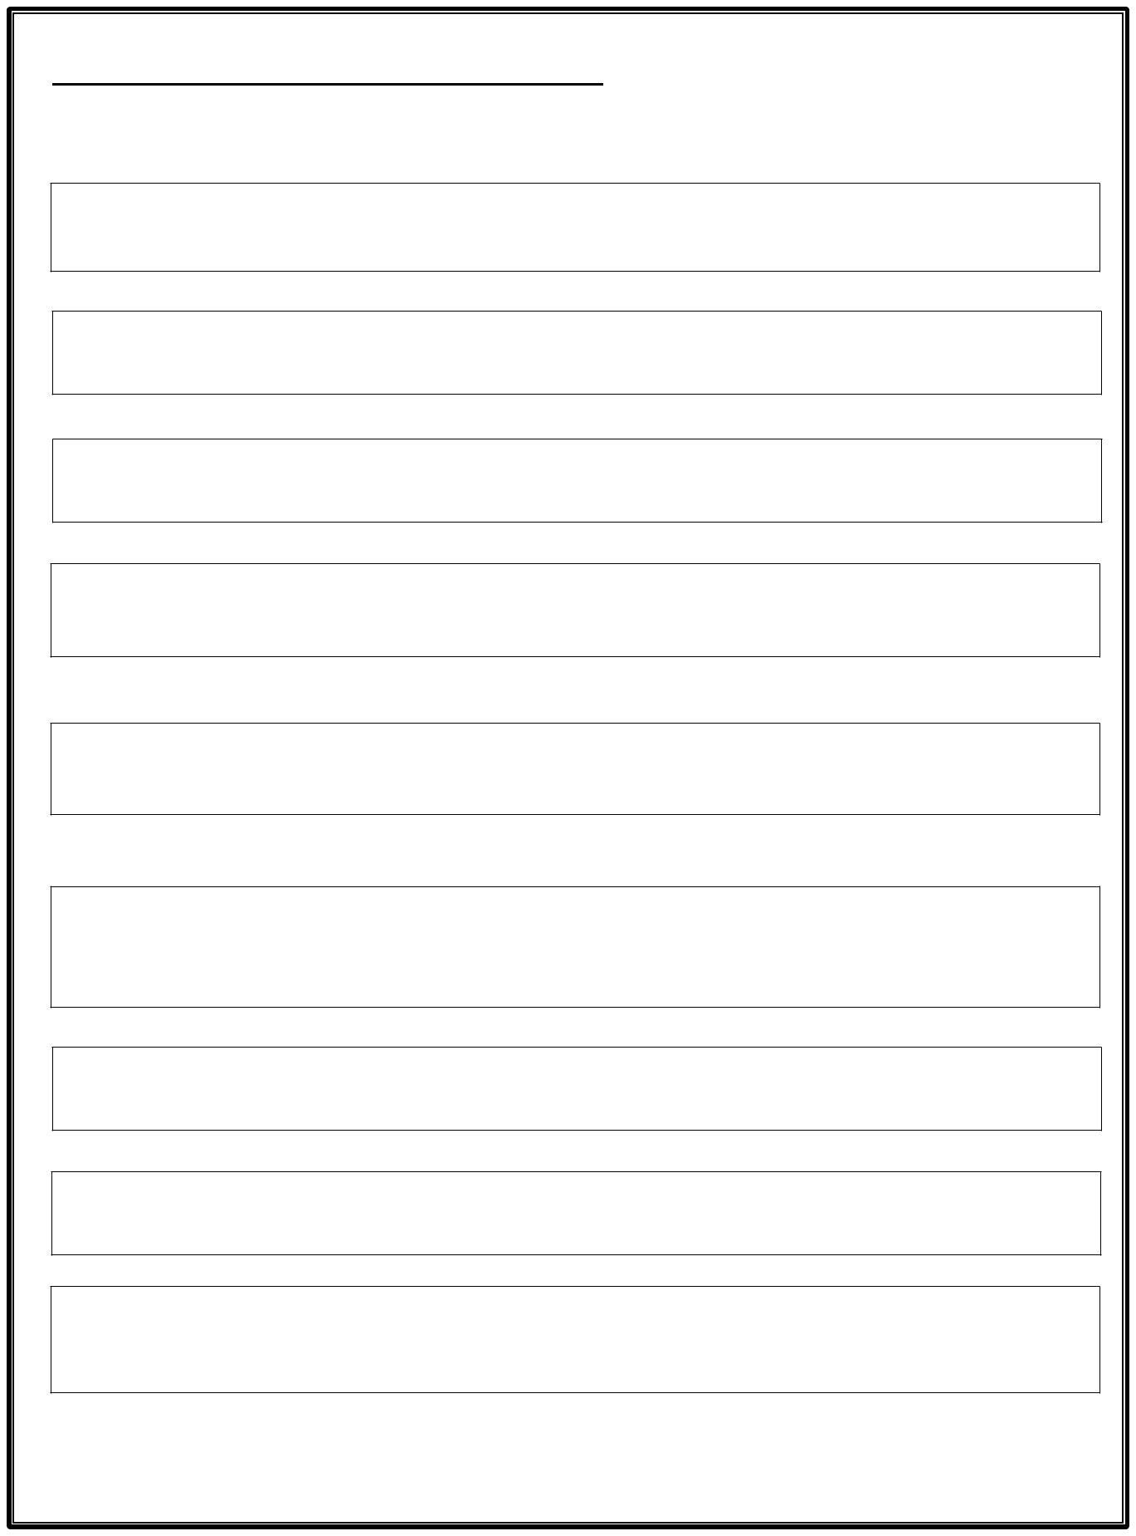
The Outbreak of War in Europe - 1939

Comprehension
1 - What date and time did the war officially start? (1)

2. Why did the war start?

3 - Who announced the speech for both Britain and France? (1)

4 - In your opinion, how did the British prime minister feel about the announcement? (2)

5 - What phrase from the final sentence in paragraph two might have been ‘the words most feared by all’? (1)

6 - Why do you think the invasion came after Germany signed the Molotov-Ribbentrop pact with the Soviet Union? (2)

7 - What tactic was first used against the Polish army? (1)

8 - Approximately, how long ago was the announcement? (from the text) (1)

9 – How is the war described in paragraph four?

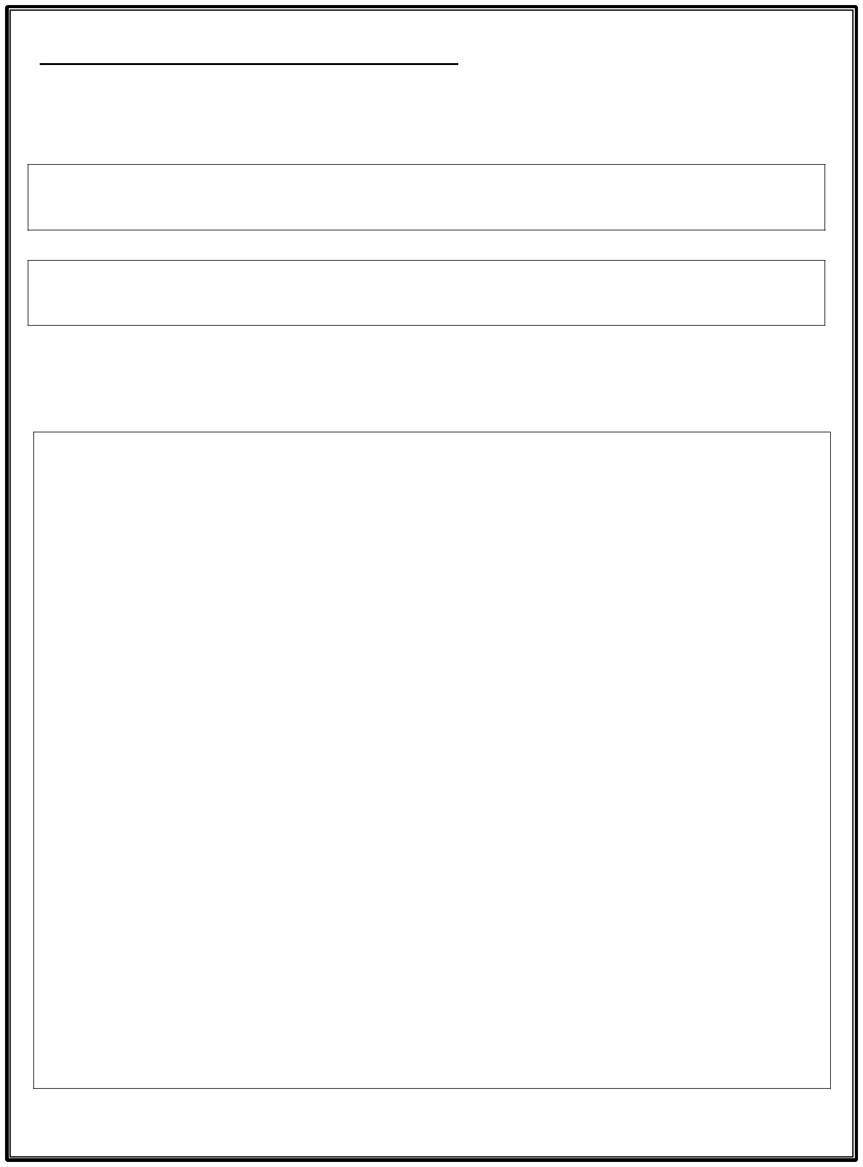
The Outbreak of War in Europe - 1939

Grammar

10 – Copy an adverb and an adjective from the final sentence of the text. (2)

11 – Speech marks are used in the second paragraph – why? (1)

Extension

12 – Write a short newspaper article declaring the outbreak of war. Remember to include: a headline, sub-heading and quotes. (3)

