Poetry Task
Last term we created a poem using the ABAB structure called a ‘QUATRAIN poem’ where every second line of a 4 lined stanza ended with a rhyming word.
For example:
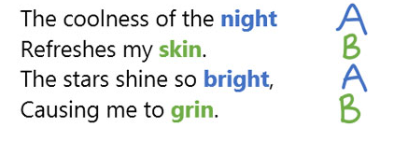
In this task, you are challenged to create a poem using this structure with the theme of ‘WIND’.
Before starting try to think of words or phrases you would associate with wind and use them in your poem. Aim for anything between 2 and 5 stanzas for your poem!

Good Luck! You can use the templates provided below if you wish.

