Revision of w h j v y z.

Look at the picture and write the word in the boxes below.

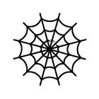

|  |  |  |
| --- | --- | --- |
|  |  |  |

|  |  |  |  |
| --- | --- | --- | --- |
|  |  |  |  |

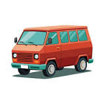



|  |  |  |
| --- | --- | --- |
|  |  |  |

|  |  |  |  |
| --- | --- | --- | --- |
|  |  |  |  |

|  |  |  |
| --- | --- | --- |
|  |  |  |

|  |  |  |
| --- | --- | --- |
|  |  |  |

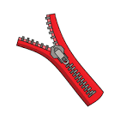

Answers

web

help

jump

van

yes

zip