

Bankhead Primary School
66 Caldwell Avenue
Glasgow G13 3AS
Phone 0141 959 3531

Head Teacher

Mrs Celine McKinlay

Headteacher@bankhead-pri.glasgow.sch.uk
15^{h} January 2021
Dear Parent/Carer,

Bankhead’s Protocol for Pupils, Parents and Staff in the Provision of Digital Learning as part of Remote Learning

Teachers are continuing to adapt their forward planning to teach online. In addition to Google Classrooms teachers may set up Teams meetings as a way of engaging children. For example a ‘sharing time’ at the end of the week to help the children review their learning and to allow the children to see their teacher and their classmates.

Please read the remote protocol and if you agree with it you do not need to do anything. However, if you DO NOT want your child to participate in Teams then you must contact the school.

We still have some paper packs of learning materials in school so if you haven’t collected your child’s pack please do so between 9am-3pm. Next week there will be a variety of ways in which children will be learning e.g. planned learning from paper packs which have been uploaded or pre-recorded lessons on Google Classrooms.

Our goal, providing we can access the internet which has been challenging this week, is for every family to engage in online learning. It is easier for pupils, parents and teachers to engage together in online learning whereas it is harder to support children with new learning while children are using paper copies. Not all children have yet engaged with Google Classrooms and we encourage you to access this resource. There is an expectation that all Primary 7 pupils will engage with Google Classrooms every day on their iPads. We have just discovered that you can access Google Classrooms through a PlayStation/an Xbox which might help some of our families (please see below for how to do this).

We will keep in regular contact with you and please contact the school if you have any queries or concerns.

Yours sincerely

Celine McKinlay

Head Teacher

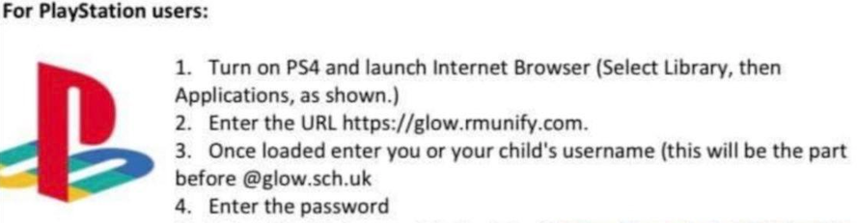

Follow this link for a useful video tutorial: https://youtu.be/mHTHaXhccDE

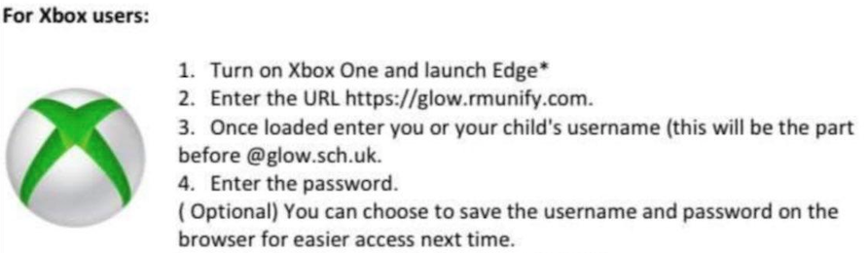

Follow this link for a useful video tutorial: https://www.youtube.com/watch?v=rWTwAfLKbkU



