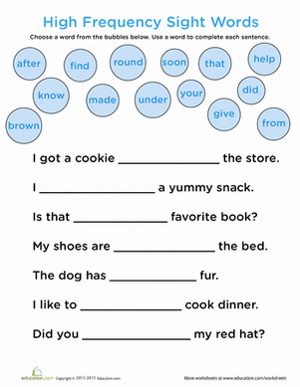

Can you write some of your own sentences using common words at the top of the page.

________________________________________________________________________________________________________________________________________________________________________________________________________________________