How to view Payment History
1. Navigate to www.parentpay.com and log in.
2. Navigate to your Home screen.
3. From the menu, select Transaction history > Payment history.
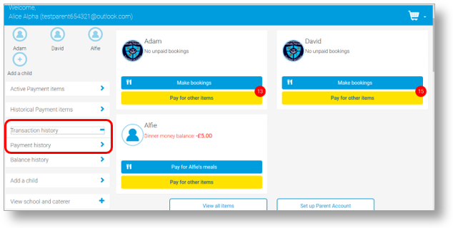
4. Select the name of the child, the payment item, and the date range you wish to view.
5. Select Search
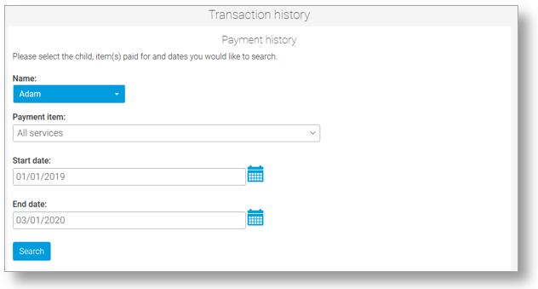
6. You will see a full list of all the transactions carried out during the selected period.

