How to pay for items
Whenever a school creates an item to pay for (such as a trip, uniform, or a club) they select which pupils or staff members to assign to the item. This assignment allows parents or carers to log into the ParentPay system and make a payment. To pay for items, please follow the steps below:
- Navigate to www.parentpay.com and log into your payer account
- Select one of the 3 options to view the items for payment
a. Pay for <child’s name=””> meals – located below the child’s name in the pupil tiles in the centre of the page. This will only give the option to pay for school meals for a single child.
b. Pay for other items – located below the option to pay for meals in the pupil tiles in the centre of the page. This will only provide details of any items assigned this child.
c. Active payment items – on computers, this is located in the menu on the left side of the page. For mobile devices, this can be accessed by selecting the menu icon in the top left corner. This will list all items for payment assigned to any children or staff members linked to your payer account.

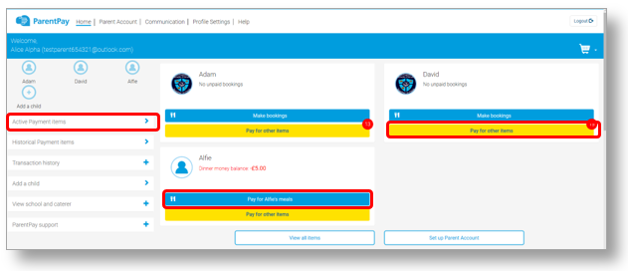

3. Select View against the required item for payment
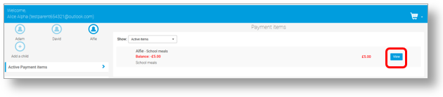
4. Enter the amount to pay, quantity required, or any other requested information.
5. You can either select Add to basket or you can pay via Bank Transfer if you have enabled this feature
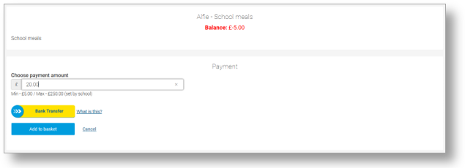
6. If you have selected Add to basket, select the basket icon in the top right corner of the screen to review the payment. You will then have the option to pay via Parent Account credit, Bank Transfer, Visa Checkout or Other payment method.
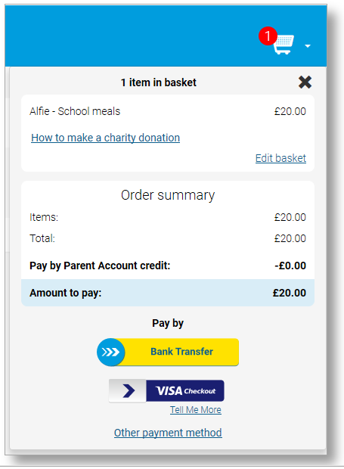

NOTE: If there is any credit in the Parent Account, this will be used to pay for the items. If the total of the items to pay for is greater than the Parent Account balance, the difference can be paid by other methods

7. Complete the payment process. Once the payment has been completed, a confirmation message will be displayed

