How to make meal or event bookings
If your child’s school makes use of the ParentPay booking service, you will be able to book your child’s meals and/or event places in advance of the session. This helps the school minimise food waste, and reduce administrative burden on the school staff.
To check whether your child’s school uses the booking feature, select the child you wish to view. The bookings option will be available in the left side menu (or in the menu drop down if using a mobile device).

Making bookings
1. Go to www.parentpay.com and log in
2. Select the child to make bookings for
3. Select Bookings > Make or view bookings
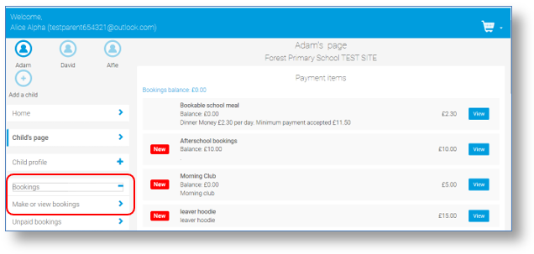
4. Select the time of day that you wish to make a booking for
5. Select the week to view
6. Select Make or view bookings
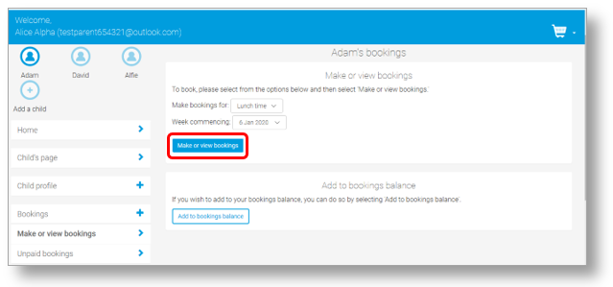
7. You will then be presented with a booking screen. Schools can opt for varying functionality, so you will be see one of the following formats:

- Menu selections: Book a meal by selecting from the menu choices shown (please note that some menu’s may require you to select dessert also)
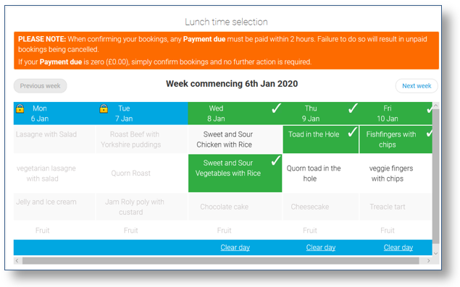
• Booking with menu to view: Book a meal or event. Menu shown, but choices cannot be selected. You simply book to say that your child would like a meal on that day.
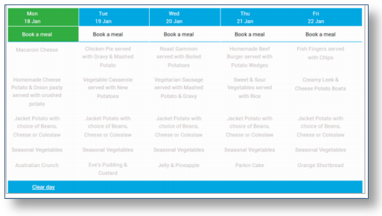
- Booking only: Book a meal or event for a specific day. No menu shown.
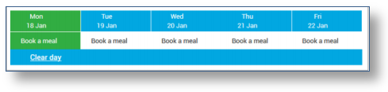
8. Make the required bookings
9. A summary will be displayed at the bottom of the page with any previous unpaid bookings shown in red
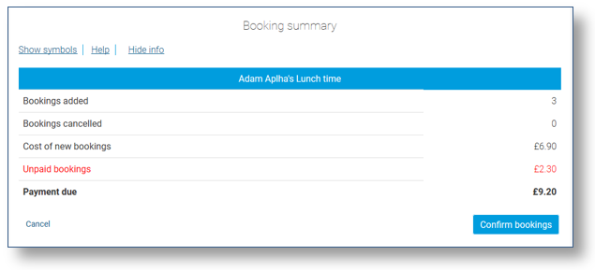
WARNING: Any bookings must be confirmed and (if required) paid for within 2 hours of selecting them. Failure to do so will result in the bookings being automatically cancelled.
10. Review the booking summary, and select Confirm booking.
11. Any credit in your Parent Account will be used to pay for the meals. Any remaining cost can be paid by Bank Transfer (if enabled), Visa Checkout or Other payment method

