How to change your username or password (and other profile settings)
When creating your ParentPay account, it is a requirement to provide an email address which is used as your username. You will also have been required to set up your own password. It is important to keep your email address up to date so that you can continue to receive communications from your school(s) and organisations. The email address is also used if you need to change your password or log a support issue. Should your email provider ever change, it will be necessary to update your username.
NOTE: ParentPay advise that you should use a personal email address rather than a corporate email address to minimise the loss of account access when moving jobs.

How to change your username
1. Navigate to www.parentpay.com and log into your account
2. Select Profile settings > Username
3. Select Change username
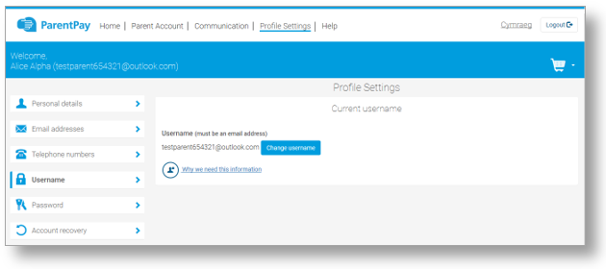
4. Enter the current Password, the new username email, and confirm the username email
5. Select Send verification
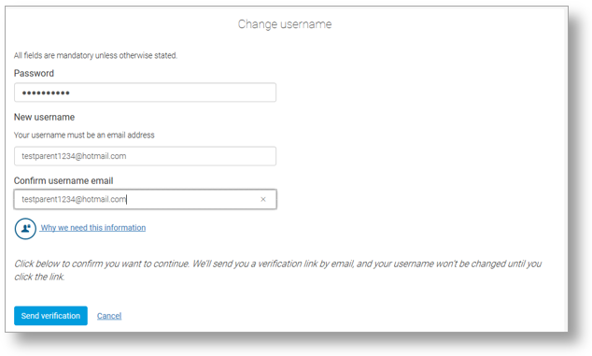
6. An email will be sent to the new email address
7. Open the email and click on the link to verify the email address and change the username.
8. Log into ParentPay with the new username

How to change your password
1. Navigate to www.parentpay.com and log into your account
2. Select Profile settings > Password
3. Select Change password
4. Enter the Existing password, the New password, and Confirm new password
5. Select Save changes

How to set an email address for account recovery
The account recovery email address is used to assist in the recovery of the account if the username is ever forgotten.
1. Navigate to www.parentpay.com and log into your account
2. Select Profile settings > Account recovery
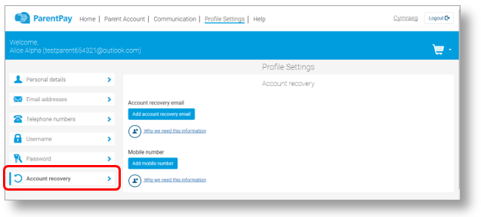
3. Select Add account recovery email
4. Enter the current password, the new account recovery email, and confirm the account recovery email
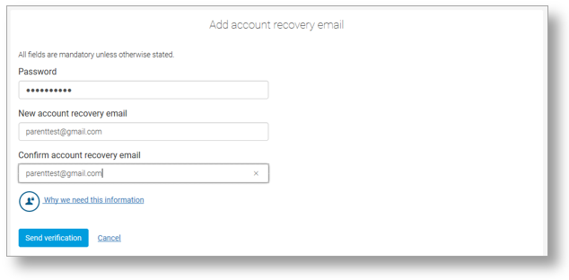
5. Select Send verification
6. A verification email will then be sent to the email address entered
7. Open the email and select the link to verify the address

How to set a mobile phone number for account recovery
The account recovery mobile phone number is used to inform you of any balance alerts that you may choose to receive. It can also be used to help you regain access to your ParentPay account if the log in details are forgotten.
The mobile phone number is shared with the school(s) that your child(ren) attend unless otherwise indicated.
1. Navigate to www.parentpay.com and log into your account
2. Select Profile settings > Account recovery
3. Select Add mobile number
4. Enter the password, new account recovery number, and confirm account recovery
number
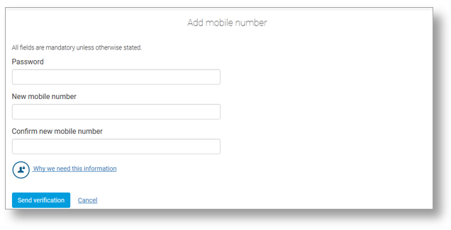
5. Select Send verification
6. A PIN will then be sent to the number that has been entered
7. Enter the PIN into the ParentPay site to verify the mobile number
