How to add a child to your account or merge accounts together
One of the key features of ParentPay is the cross-school login functionality. This enables parents or carers that have children attending multiple ParentPay enabled schools to have a single account for up to 15 children.

Adding a child to your account using activation codes provided by the school
Whenever a school launches ParentPay for the first time, or a child starts at a school that is already using ParentPay, each pupil will be issued an activation letter containing unique activation codes.
If you have never used ParentPay previously, you will need to use the codes in one letter to activate your account. (please see Payer guidance- How to activate your account)
The activation codes in any subsequent letters can then be used to add a child to the original account.
1. Navigate to www.parentpay.com and log into an existing activated account.
2. If using a computer, select the Add a child icon from the top left of the home page or from the menu on the left
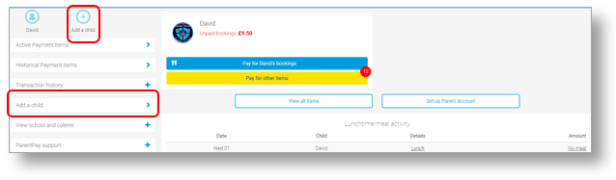
If using a smart phone, or other mobile device, select the menu icon from the top of the page, and select Add a child.
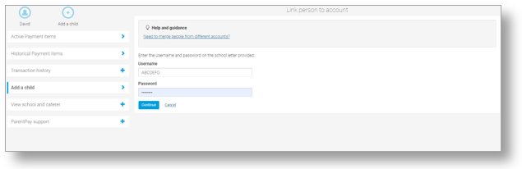
Enter the activation codes exactly as written on the activation letter and select Continue.
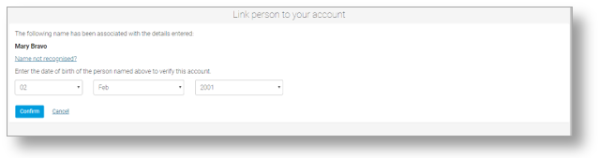
Enter the date of birth for the child you wish to add
Click Confirm
You will see confirmation that the child has been added successfully and you will be able to make payments for the newly added child.

Merging two or more logins together
If you have more than one log in to payer accounts on ParentPay it is possible to merge them together providing the steps below are followed:
• Select which of the logins will be the primary account that the other(s) will be merged into.
• Ensure that the secondary account(s) have a Parent Account balance of £0.00. If there is a Parent Account balance, this must be withdrawn before the account is merged. If the balance is not zeroed before the merge is attempted, an error message will be displayed.
NOTE: Any payment history, transaction history, or Parent Account statements for the secondary account(s) cannot be accessed after the accounts have been merged. Print any reports or records that may be required for future use.
• Ensure that the total number of pupil/staff records that will be combined by merging the accounts will not exceed 15. A ParentPay parent account can currently only manage15 pupils. If the combine total exceeds 15, an error will occur, and the merge will not complete.
• Ensure that only pupil or staff accounts will be merged. ParentPay manager accounts (used for administrating the ParentPay system) cannot be merged with pupil or staff accounts (used for making payments for meals or other items).
Once all of these points have been completed/confirmed, the accounts can then be merged
1. Log out of all ParentPay accounts.
2. Log into the primary account that will become the master account once the merge has been completed.
3. If using a computer, select the Add a child icon from the top left of the home page.
If using a smart phone, or other mobile device, select the menu icon from the top of the page, and select Add a child.
4. Enter the username and password of the secondary account that is to be merged into the master account.
5. Select Continue.
6. Check the details of the account to be merged, and select Confirm.
All of the pupil/staff records from the secondary account(s) will then be transferred to the master account.

