How to activate your account
Before you can activate a ParentPay account, you will need the activation letter which is provided by your child’s school. If you don’t have this, please contact the school directly to request a copy.
- Go to www.parentpay.com
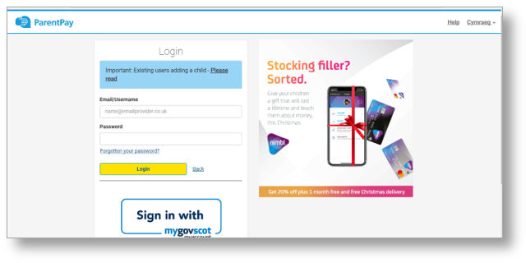
- Type in the username and password provided in the activation letter from school, be
sure not to confuse the letter l (for lima) with the number one (1) and the number 0
(zero) with the letter o (for oscar).
NB The user details are case sensitive and for one-time use only.They will become invalid after account activation

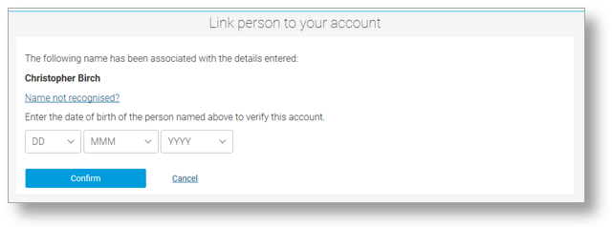
- Confirm the details are correct and enter the date of birth for your child and click Confirm
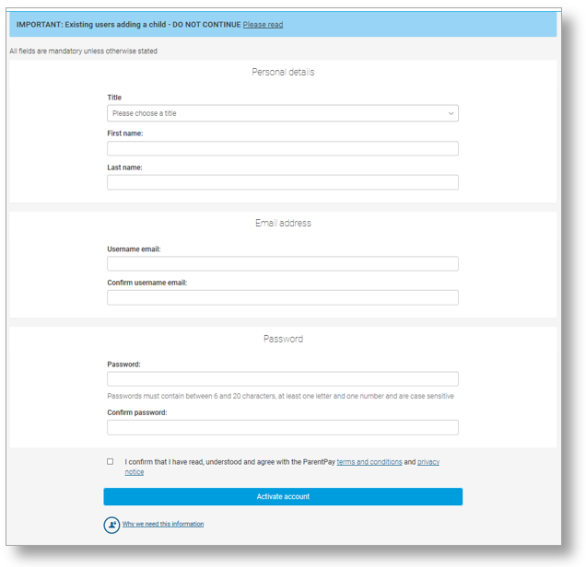

- Follow the on-screen instructions to successfully activate the account. You will need to enter in their name, an email address and select a password for the account (your email address will become your username)
Read the ParentPay terms and conditions and click in the box to accept at the bottom of the page then click Activate account.
- A verification email will be sent to the user. They will need to click on the link within the email
to complete the process and access their account.

