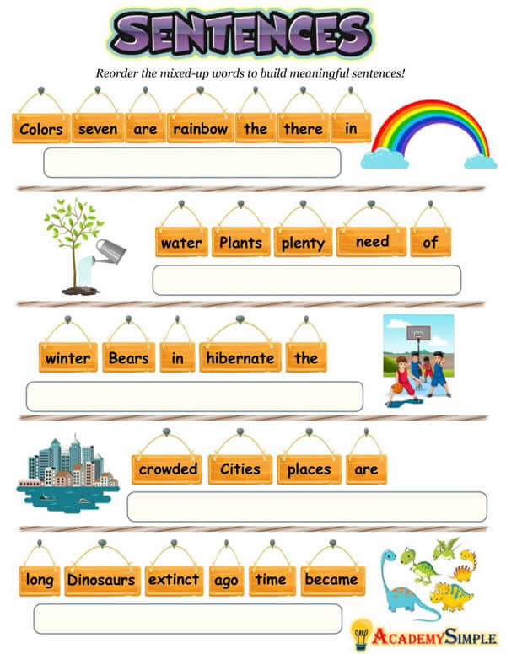

Can you rewrite the sentences in the correct order. Remember to look out for capital letters and full stops. This will be a clue to help you work out the first word and the last word of the sentence.