How to use colon- Practice Sheet

Below are the 4 main reasons we have looked at for using a colon:

- To introduce a list
- To separate two independent clauses when the second explains the first
- To introduce a quotation
- To emphasise a single word

Now use these rules to complete sentences below and add the colons required!

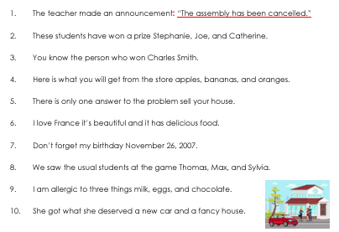
Write 5 sentences of your own that use colons!

1.

2.

3.

4.

5.

