Bankhead Primary School

Anti-Bullying

Position Statement

April 2023

**School Background**

Bankhead Primary is a diverse school community. We continually strive to raise achievement, attainment and positive expectations of our pupils. We are a ‘Rights Respecting School’ which places considerable emphasis on creating a culture of tolerance and respect for all which in turn creates a positive ethos for learning and achievement. We believe **everyone** in our school community is entitled to feel valued, safe and free from all forms of abuse.

**Our school values are**;

* Ready
* Respect
* Safe

**Our school motto is;**

‘Working together to achieve our best.’

**Our vision is;**

‘To nurture secure and respectful individuals with life-long aspirations.’

We support the Scottish Government’s vision on bullying prevention.

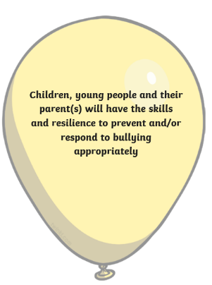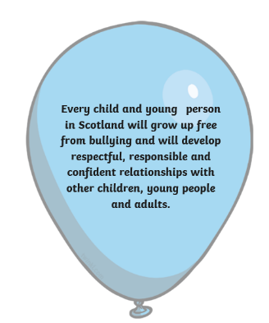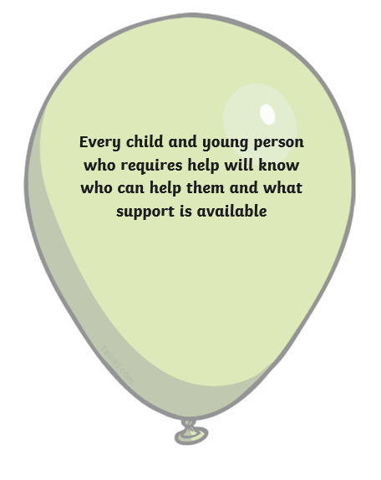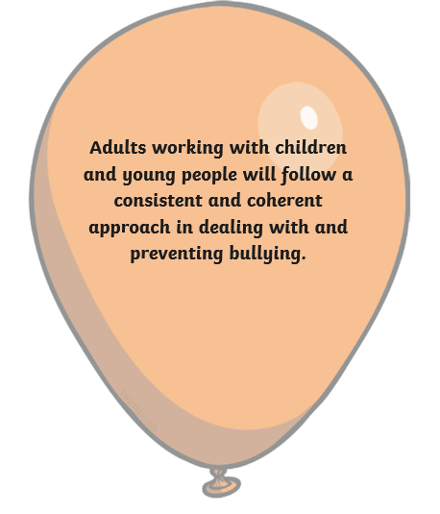

**Rationale**

We believe that our pupils should have every opportunity to learn and develop the necessary skills required to flourish in education, future work and life. We aim for our pupils to become; successful learners, confident individuals, effective contributors and responsible citizens. We aim to achieve this by providing quality teaching and learning experiences and by promoting a nurturing and inclusive ethos.

As a school we aim to promote, support and maintain an anti-bullying strategy which takes account of local and national guidance on best practice.

Aims:

* To make every effort to ensure that all young people are free to learn in a safe and secure environment without the fear of bullying. It is every child’s right not to be bullied.
* To ensure that there is a common understanding of what bullying is and where it takes place.
* To develop and maintain a partnership approach among parents, carers, pupils and staff which develops school ethos and tackles the issue and impact of bullying.
* To promote a positive ethos in Bankhead Primary that fosters the development of skills, self-esteem and resilience within our pupils.
* To equip our pupils with the necessary skills to tackle the behaviour and impact associated with bullying in our school environment and in the wider world.
* To support those who have been affected by bullying and those who display bullying behaviours.

**Bullying: A Working Definition**

In line with national guidance, bullying is defined as:

“Bullying is both behaviour and impact; the impact is on a person’s capacity to feel in control of themselves. This is what we term as their sense of *agency*. Bullying takes place in the context of relationships; it is behaviour that can make people feel hurt, threatened, frightened and left out. This behaviour happens face to face and online.” (Respectme, 2015)

Bullying behaviour can include:

* Being called names, teased, put down or threatened face to face and/or online.
* Being hit, tripped, pushed or kicked.
* Having belongings taken or damaged
* Being ignored, left out or having rumours spread about you
* Sending abusive messages, pictures or images on social media, online gaming platforms or phone
* Behaviour which makes people feel they are not in control of themselves or their lives
* Being targeted because of who you are or who you are perceived to be
* Prejudiced based bullying based on an individuals’ actual or perceived identity; it can be based on characteristics unique to a child’s identity or circumstance.

Bullying is a breach of children’s rights examples of prejudice-based contexts in which bullying could manifest include:

* Asylum seekers and refugees
* Body image
* Disability bullying
* Gender and sexism
* Homophobic bullying
* Homelessness
* Looked after children
* Peer pressure
* Racial bullying
* Religion and belief
* Sectarianism
* Young carers

The Equality Act 2010 makes it unlawful to discriminate against people with a protected characteristic. These are;

* Age
* Disability
* Gender reassignment
* Pregnancy and maternity
* Marriage and Civil partnership
* Race
* Sex
* Religion and belief
* Sexual orientation

There are a number of potential signs of bullying. All members of our school community should be vigilant in looking for these:

* Change in school attendance
* Change in achievement levels
* Unexplained injuries or torn clothing
* Change in appearance
* Change in sleep pattern
* Social withdrawal or isolation
* Changes in eating pattern
* Mood changes
* Depression
* Suicidal thoughts
* Changing social media accounts

Bullying can have a lifelong impact on children and our whole school community should be vigilant for signs, should be confident in identifying and reporting it and should be committed to supporting anyone who is being bullied or is displaying bullying behaviour towards others.

Bankhead Primary

Community Response

**Promoting a Positive Ethos**

At Bankhead Primary we believe that by creating a positive school community which celebrates diversity and inclusion, we can work together to minimise the occurrence of bullying. We have a variety of strategies in place to achieve this.

**Whole School**

* All staff aware of latest definitions and national/local authority position on bullying.
* All staff aware of forms of bullying, taking into account modern day issues e.g. use of social media.
* The school creates a positive ethos and a culture of respect which staff model
* Annual focus on Anti-Bullying (November)
* Assemblies which explore core issues
* Certificates to celebrate Success/Build Self-Esteem
* Pupil Voice/Opinion sought through pupil council, etc
* Whole school sanctions used effectively.
* Bullying incidents recorded, monitored and evaluated.

**Responsibility:** All staff, pupils and parents

**Classroom**

* Circle Time/Small group reflection
* Planned opportunity for pupils to be educated on bullying through Health and Well Being.
* Class charters/class vision
* Classroom Culture.
* Promotion of positive behaviour evident in all classes
* Staff listen /observe and deal with bullying as outlined in “Every Child is Included and Supported”.
* The development of the four capacities takes place within learning experiences, which will equip learners with the skills necessary to deal with bullying incidents

**Responsibility:** Class teachers, SLT, pupils

**Playground**

* Playground staff to monitor and report concerns.
* Use of play activities to promote positive relationships.
* Playground PALS to promote friendships with younger pupils.
* Buddies

**Responsibility:** All staff, pupils

**Partnership Working**

* Meetings with parents/carers when bullying has been identified.
* Bankhead Primary operates an open-door policy
* Parent Council
* Consultation of parents at regular intervals.
* Visits e.g. NSPCC, Sense over Sectarianism, CEOP, Chaplaincy Team. Local Police

**Responsibility:** Class teachers, SLT, Partners

**I’m a parent/carer who suspects bullying – What should I do?**

Bullying can affect a child’s sense of agency, so it’s important that your response helps your child to regain a sense of control.

* Firstly, listen to what your child is saying.
* Don’t panic – it’s important to remain calm, as this provides reassurance for your child.
* Ask then what they want to do, this will allow you to understand what kind of support your child might need. It is also important that your child feels they are being heard.
* Contact our school and arrange to speak with a member of our SLT who will listen to your concerns and will initiate our anti-bullying actions which are detailed within this policy.
* We will keep in contact with you and advise you how our investigation is proceeding, we would encourage you to be involved in action planning and supporting.

**I’m a member of staff who suspects bullying – What should I do?**

It is extremely important that we are vigilant for signs of bullying. Staff should be aware of the most up-to-date definitions, language and procedures for handling incidents of bullying behaviour in schools. The health and wellbeing of our pupils is the responsibility of all adults working within the school environment.

* Listening to the child and giving them the right support is crucial.
* Report any concerns to a member of SLT who will initiate the school’s anti-bullying actions.
* Relationships are crucial, it is important that children feel they have trusted adults to speak to.

**I’m a pupil who has witnessed bullying – What should I do?**

Witnessing bullying can be upsetting and it can be difficult to know what the right thing to do is. Please don’t keep bullying a secret, it’s important that we take action to keep our school a safe place. Here’s some ideas of things you can do.

* Tell an adult – sometimes we can worry about telling adults things as we are worried they might be angry or will overreact, but it’s really important that the person experiencing bullying behaviour gets help and support.
* Make it clear that you don’t agree with bullying behaviour.
* Be a friend
* Don’t join in

**I’m being bullied – What should I do?**

There’s no one right answer for dealing with bullying behaviour, but here are some suggestions which you could use.

* Tell someone, for example a friend or a trusted adult in school or at home. Telling someone doesn’t always stop the bullying, but it really does help. Having someone to listen and to help you regain your sense of control is really valuable.
* Don’t bottle things up
* If it’s happening online, block and report.
* Keep a diary of what’s happening – this is really useful for helping you make sense of what’s going on and can be really useful in helping you to speak with someone about what’s been going on.
* Tell them to stop – the person who is bullying you may not be fully aware of how their behaviour is affecting you. Some people aren’t approachable and this may not work for you, you can decide.
* If you feel you cannot speak to your family or someone in school, please call **ChildLine on (0800 1111) or online at** [**https://www.childline.org.uk/**](https://www.childline.org.uk/)
* Childline also have lots of brilliant information for children to help them understand bullying – here’s the direct link: <https://www.childline.org.uk/info-advice/bullying-abuse-safety/types-bullying/>

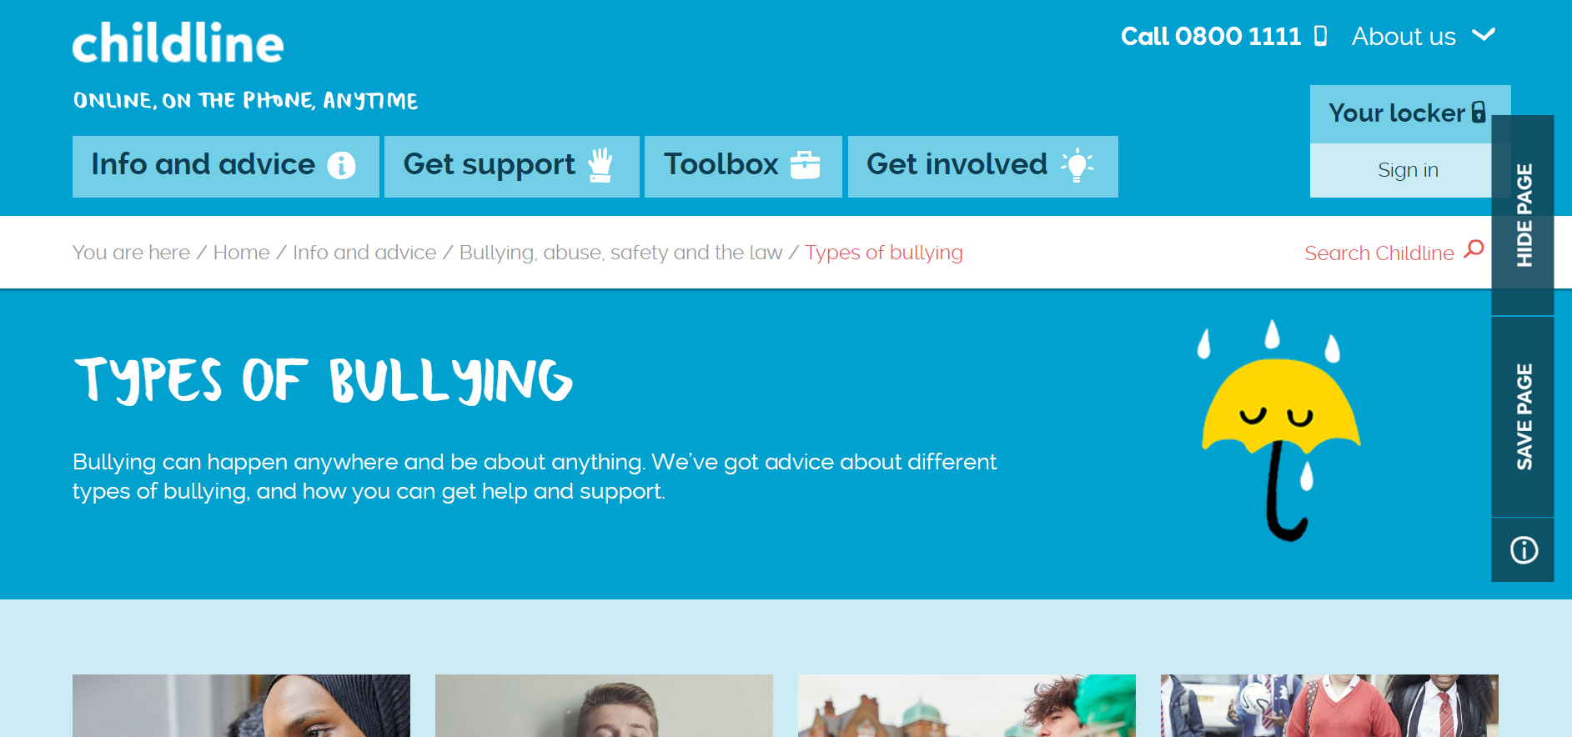

* Respect Me have a helpful website too – here’s the direct link: <https://respectme.org.uk/page-3/page-4/>

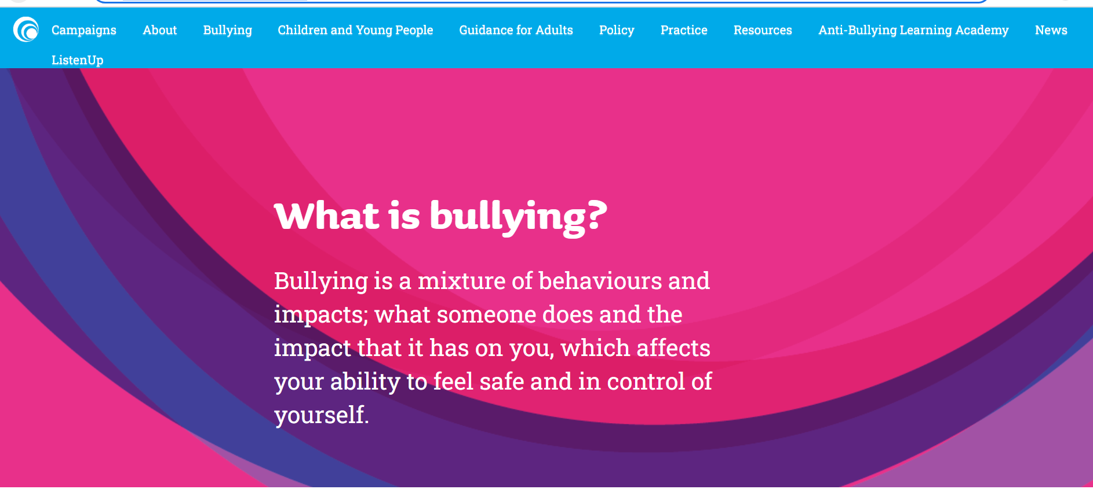

**Handling Bullying Incidents**

Despite our continued focus on creating and maintaining a positive school culture, we are fully aware that bullying can still occur.

In the event of a report of bullying we endeavour to:

* Treat all bullying behaviour seriously
* Ensure “reporters” of bullying have anonymity, safety and that the matter will be fully investigated.
* Work in partnership with parents/carers and pupils
* Ensure a consistent approach is taken when incidents are reported.
* Ensure incidents are recorded accurately using appropriate recording format in line with GCC Procedure.

| A close-up of a logo  Description automatically generated with medium confidenceA close-up of a logo  Description automatically generated with medium confidenceBankhead Primary  Handling of Bullying Incidents | |
| --- | --- |
| Phase 1 – Initial Phase | When a concern is raised, expressing that a child has been, or feels that they have been bullied. The following actions will be taken.   1. A designated investigating officer will speak to the “reporter” this will enable the gather information necessary for understanding the situation. 2. Investigating officer will open a record on the incident within the SEEMiS Bullying and Equalities module. 3. Investigating officer will work to re-assure the “reporter” that the matter will be treated with seriousness and will be fully investigated. Investigating officer will usually advise the “reporter” steps which will be taken. 4. A copy of this policy should be offered to the “reporter” and their parent/carer. |
| Phase 2 – Speaking with the person experiencing bullying behaviour/Person displaying bullying behaviour | 1. In the case that the “reporter” is not the person experiencing the bullying behaviour, the investigating officer will make contact with them in order to re-assure, support and establish the nature of behaviour experienced. 2. Investigating officer will also make contact with the person displaying bullying behaviour. This will be approached in a way which is suited to the age/stage/feelings and understanding of the child(ren) and all interactions will be sensitive. Examples of how this may be approached include; talking, drawing, using figures, completing a wellbeing wheel. |
| Phase 3 - Investigation | 1. Investigating officer will use pastoral investigation materials to support structured gathering of evidence. As we take any disclosure of bullying behaviour, this can take a few days to complete, your investigating officer will discuss timescales and will ensure you are aware of progress. In conducting a pastoral investigation, we may do the following:   Speak with groups or other individuals within the classroom or wider school.  **Why do we do this?**  Speaking with other children can be an extremely effective way of identifying patterns and looking for information which may not always be obvious to adults.  Speak with relevant staff and partners involved in the care of pupils.  **Why do we do this?**  Adults who work closely with children know them well and have a good understanding of every child’s needs. Staff can often see patterns or changes in behaviour.  Speak with parents/carers involved in a child’s care.  **Why do we do this?**  Parents and carers know their child best. They are a good source of information around significant changes in their child’s behaviours.  We may carry out playground or classroom observations.  **Why do we do this?**  This can allow us in a discreet way to observe relationship dynamics and can allow us to begin planning for how to best make any adjustments or changes which could support.  We may explore GMWP results.  **Why do we do this?**  We carry out the GMWP as part of our ongoing commitment to wellbeing. The GMWP can be useful in supporting us to see any significant changes in a child’s wellbeing over time.   1. Once the investigation has been carried out, information will be collated and discussed. Time will be spent with the person experiencing bullying behaviour/Person displaying bullying behaviour discussing ways in which behaviours and attitudes can be changed – the aim of this activity will be to explore restorative approaches which are agreeable. 2. Findings and agreed action will be accurately reported in line with GCC policy. |
| Phase 4 – Action Planning | 1. Parents/carers (and where appropriate) other adults involved in child’s care will be invited to either have a telephone consultation/face to face meeting where we discuss progress and findings. 2. Parents and pupils will be invited to work on developing an action plan which outlines the agreed restorative approaches. These could include; positive play sessions, working together to look at friendships, resolving conflicts, assistance from partners, etc. Action taken will be appropriate to the situation and age and stage of pupil. 3. Investigating officer will record the outcome of the investigation within the SEEMiS Bullying and Equalities module. 4. Physical records of the investigation will be held in a locked cupboard in the ‘Pastoral Investigations’ file. |
| Action 5 - Monitoring | 1. The investigating officer will follow up to ensure restorative work undertaken is impacting positively on pupils. 2. Parents/Carers are actively encouraged to participate in this and any contact is most welcome, as incidents are most skilfully resolved when all parties work together to promote acceptable outcomes. |

**Further Support and Information**

* Respectme: [www.respectme.org.uk](http://www.respectme.org.uk)
* UNCRC: [www.unicef.org.uk/what-we-do/un-convention-child-rights](http://www.unicef.org.uk/what-we-do/un-convention-child-rights)
* Bullying UK: [www.bullying.co.uk](http://www.bullying.co.uk)
* YoungMinds: [www.youngminds.org.uk](http://www.youngminds.org.uk)
* Child Exploitation and Online Protection (CEOP) [www.ceop.police.uk/safety-centre](http://www.ceop.police.uk/safety-centre)
* Thinkuknow: [www.thinkuknow.co.uk](http://www.thinkuknow.co.uk)
* Childline: [www.childline.org.uk](http://www.childline.org.uk)

|  |
| --- |
| Pastoral Investigation Sheet (Part One)  Group Interview Sheet |
| Interview Date and Time:  Persons Interviewed: |
| How are things in P __? |
| How are relationships in P __? |
| Is there anyone in the class you are concerned about? |
| Discussion around specific pupils and who they play with/points raised during focus group interview. |
| Interview carried out by: |

|  |
| --- |
| Pastoral Investigation Sheet (Part Two)  Staff Interview Sheet |
| Significant Behaviours (Child A - ) |
| Significant Behaviours (Child B - ) |
| Are there any concerns around the behaviour of either pupil in the playground/classroom? Have any incidents been observed between the pupils? |
| Any other points to be considered? |

|  |
| --- |
| Pastoral Investigation Sheet (Part Three)  Parent Interview Sheet |
| Main Concern |
| Information on specific incidents |
| Any other issues |
| **Parent Outline**   * Carry out Wellbeing discussion * Interview with individual * Class interviews * Staff interviews * Set Feedback date/review date   Agreed Date for next contact: |
| Interview carried out by: |

|  |
| --- |
| Pastoral Investigation Sheet (Part Four)  Debrief |
| Significant Findings |
| Monitoring Procedures |
| Agreed Next Steps |
| Investigating Officer ____________________________________  Parent/Carer ___________________________________________  Pupil ____________________________________________________ |

|  |  |  |  |  |  |  |
| --- | --- | --- | --- | --- | --- | --- |
| **Playground Observation Profile** | | | | | | |
| **Pupil Name:** |  | | | | | |
| **Class:** |  | | | | | |
| **Observation Date:** |  | | | | | |
|  | | **Not at all** | **Rarely** | **Sometimes** | **Often** | **Always** |
| **Playground Behaviour** | | | | | | |
| Engages with others | | 1 | 2 | 3 | 4 | 5 |
| Plays appropriately | | 1 | 2 | 3 | 4 | 5 |
| Looks engaged in play | | 1 | 2 | 3 | 4 | 5 |
| Has a friend group | | 1 | 2 | 3 | 4 | 5 |
| Is included in games and activities | | 1 | 2 | 3 | 4 | 5 |
| Cooperates with others | | 1 | 2 | 3 | 4 | 5 |
| Shows distress | | 1 | 2 | 3 | 4 | 5 |
| **Total Score:**  **(Max 35)** | | | | | | |
| **Observer Comment** | | | | | | |
|  | | | | | | |
|  | | | | | | |
| Child Rating | | 1 | 2 | 3 | 4 | 6 |
| Child Comment | | | | | | |
|  | | | | | | |
| **Observed dynamics with significant others** | | | | | | |
|  | | | | | | |
| **Classroom Observation Profile**  **(Pastoral Concern)** | | | | | | |
| **Pupil Name:** |  | | | | | |
| **Class:** |  | | | | | |
| **Observation Date:** |  | | | | | |
|  | | **Not at all** | **Rarely** | **Sometimes** | **Often** | **Always** |
| **Classroom Behaviour** | | | | | | |
| Engages with others | | 1 | 2 | 3 | 4 | 5 |
| Appears withdrawn | | 1 | 2 | 3 | 4 | 5 |
| Looks engaged in learning | | 1 | 2 | 3 | 4 | 5 |
| Can talk about learning | | 1 | 2 | 3 | 4 | 5 |
| Is included in classroom activities | | 1 | 2 | 3 | 4 | 5 |
| Cooperates with others | | 1 | 2 | 3 | 4 | 5 |
| Shows distress | | 1 | 2 | 3 | 4 | 5 |
| Is isolated | | 1 | 2 | 3 | 4 | 5 |
| Relates well to adults | | 1 | 2 | 3 | 4 | 5 |
| **Total Score:**  **(Max 45)** | | | | | | |
| **Wellbeing Indicators (Comment on observed classroom behaviour under these categories)** | | | | | | |
| Safe, Healthy, Achieving, Nurtured, Active, Responsible, Respected, Included. | | | | | | |
| **Observer Comments** | | | | | | |
|  | | | | | | |

|  |  |
| --- | --- |
| Template for Individual Wellbeing Discussion | |
| Name |  |
| Date |  |
| **Wellbeing Indicators**  **(Conversation must focus on home and school, as bullying behaviour can be evident beyond the school gate)** | |
| Safe |  |
| Healthy |  |
| Active |  |
| Nurtured |  |
| Achieving |  |
| Respected |  |
| Responsible |  |
| Included |  |
| **Discussion about Specific Issue** | |
|  | |

|  |  |
| --- | --- |
| **Bankhead Primary**  **Anti-Bullying Awareness Raising Calendar**  **2023/24**  *Update me annually and publish me on website, app and in this policy. Supply a copy to staff | |
| **August** | Anti-Bullying co-ordinator to decide on one main aspect to be taken forward. |
| **September** | Assembly: Friendships and Fallouts |
| **November** | **National Anti-Bullying Week**   * Classroom Activities * Assembly * Parent/Carer leaflet out annually and info on app and Twitter. * Staff briefing to go out annually * Anti-Bullying wall refreshed |
| **January** | Assembly: We are all different |
| **March** | Any pupil voice group to carry out awareness raising activity. |
| **May** | Assembly: Children’s Rights – Articles linked to anti-bullying |
| **May/June** | Anti-Bullying co-ordinator to review policy and language using GCC, national and respectme guidance. Also to review data and provide end of year summary. Begin designing next year’s calendar. |