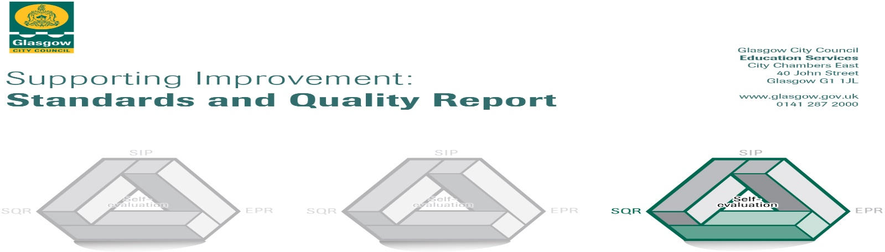

The summary report is provided for parents/careers and partners to outline our achievements this session and our priorities for next session. Throughout this session we have taken forward our priorities as detailed in our school improvement plan. Through our processes of self-evaluation, we have identified how we can improve outcomes for our children and young people.

|  |  |
| --- | --- |
|  | **Our achievements and improvements this year.** |
| **Bankhead Primary**  *‘Working together to Achieve our Best’*  In Bankhead Primary, we are very proud of our school. Our school provides a happy and nurturing environment where learners can grow and develop. Our learner quotes provide a flavour of our school environment.  *‘We never give up.’*  *‘We have kind students’*  *‘I have a nice teacher.’*  *‘We are always working hard.’*  Our values of **safe**, **respect** and **ready** are at the heart of all we do. Our school visions. Developed in session 2022/23 is, ‘To nurture secure and respectful individuals with lifelong aspirations.’  In the document which follows, we will provide an insight into our main achievements from session 2023/24  **Leadership of change**  In session 2023/24, our staff undertook Active literacy spelling and reading refresher training. Staff were also trained in how to use our newly developed writing criteria. Our P1-3 teachers were trained in ‘Talk for Writing’ approaches. Staff also participated in an online training session led by maths specialist, Lynda Keith. Our P1 teacher delivered whole staff training around how the ‘Up, Up and Away’ document can support planning. Three members of staff undertook Circle framework training. We have two members of teaching staff who are taking a lead role in the delivery of literacy and classroom culture. Our art specialist delivered parent art sessions and organised a community themed art exhibition, ‘Nature, Places and Faces’ at our local community centre. Staff received training on supporting learners with EAL, this was delivered by the Glasgow EAL team. One of our classroom teachers was trained in Bikeability and ran the programme for our P6 pupils. During the school session, our staff worked with colleagues within the learning community to moderate children’s work. Staff also worked collectively to moderate additional support plans and jotters. Staff also carried out classroom surveys.    Our school vision and values are displayed within the school and are regularly referred to. Each class created their own class vision and behaviour expectation sheet. Our pupils regularly attended the Glasgow School’s forum, leading and shaping Glasgow’s vision for pupil voice. Our Rights Respecting Schools pupils worked with our nursey partner to deliver children’s rights sessions to early years children. Our Young Interpreters took responsibility for delivering language workshops during Scots’ Language celebration.  **Learning, teaching and assessment**  This year, a writing criteria document was developed and introduced to staff. It is hoped that this will improve teacher judgements regarding attainment levels. Planners to support the teaching of non-fiction texts and digital literacy were developed, training and roll-out of these will take place in the new session. We have begun developing a framework for assessment for numeracy and mathematics, this should be completed early in session 2024-25.  **Ensuring wellbeing, equity and inclusion**  All staff took part in Equalities training during our May 2024 in service. Three members of staff participated in Circle Framework training and this will be further developed in session 2024-25. Our Rights Respecting Schools committee worked in partnership with one of our feeder nurseries to teach them about children’s rights. Our rights group also worked to develop an anti-bullying charter modelled upon the Glasgow version. The promotion of children’s rights is achieved through the development of classroom charters and children’s rights are promoted through assemblies. All classes participated in Positive Noticing Day and learned about bullying during our anti-bullying day.  Our classroom culture co-ordinator has promoted classroom routines and each class has a routine which has been shared. All classes have introduced recognition boards. In February 2024, all classes participated in Rookie Rockstars, allowing them to focus upon the importance of Wellbeing. In May 2024, children participated in a range of activities as part of Health Week.  Our P6 and P7 students worked with the organisation, ‘Bloody Amazing’ to develop a period policy for our school. Bloody Amazing also delivered workshops to our P6 and P7 pupils regarding menstrual health, as well as delivering workshops to parents and carers.  **Raising attainment and achievement**  We continue to develop our awareness of robust tracking processes through discussion at attainment meetings, held regularly throughout the year. Time has been created for staff to plan jointly to ensure greater coherence. The development of Active Literacy remains a focus, with non-fiction and film literacy as well as writing being a priority.  In November 2023, our pupils enjoyed a visit from local author Lizzie Finnegan, who also relaunched our newly developed library. Our Reading Ambassadors group were not only busy with the library relaunch but also played an instrumental role in developing events across the school year. In November classes were encouraged to share what they were reading as part of Book Week Scotland and in March, pupils engaged in the theme, ‘Read One, Become One’ a reading event which involved partners employed in different sectors coming into school and reading a book around the theme of their career. Reading Ambassadors supported the World Book Day assembly and ran the ‘Masked Reader’ event.    Our P6 classes participated in a Project-Based Learning initiative within our learning community, the theme of which was the River Clyde. Our pupils chose the theme of ‘Careers on the Clyde.’ Through this learning topic, children learned about the various jobs and careers which are available along the River Clyde. Not only did children learn about careers, they built a variety of meaningful partnerships with a range of partners including; NHS, Glasgow Humane Society, Mallen Group, First Bus, BAE Systems to name a few. Children delivered an informative presentation to their parents/carers and other pupils from schools within the learning community. This project developed a range of meaningful skills and opportunities.  This year, our P6 and P7 pupils participated in the Young Strathclyder programme. This programme raises awareness of Higher Education and is a valuable way for children to learn more about university. Learners participated in events on campus as well as within school and celebrated the end of the project with a graduation ceremony. Our P7s also enjoyed visits from the Scottish Parliament as part of their learning about democracy. Our younger P1 pupils have developed a partnership with the local care home, this has allowed children to extend their learning, working with residents of the care home on reading and listening and talking projects.  **Family Learning**  We have started to reengage families post-Covid by running a range of family learning events. These include; P1-3 Family Book Club; P1-3 and Play A Long maths sessions. Children and their families also participated in Book Bag sessions around the theme of, ‘Aliens Love Underpants’  Our parents and carers also participated in, ‘The Chat’ a national study of Relationships, Sexual Health and Parenthood’ content taught in Scottish schools. Engagement was high, with parents keen to share their views. Online safety training was offered to parents, however attendance was low at this workshop.  **Extra-Curricular**  This year our children have enjoyed a range of opportunities. After school sports clubs such as football, netball, rugby and multi-sports allowed pupils to be active. We also offered clubs such as choir. Our choir group attended a range of Christmas events, raising money for charity.  Our children had the opportunity to go on a variety of trips to support learning such as; Glasgow Film Theatre, King’s Theatre, Gallery of Modern Art. Our P7s enjoyed a successful residential to Blairvadach. Participating in a range of activities such as; gorge walking, cycling and climbing. This provided an opportunity to learn team working skills, communication and personal care skills in a real world setting beyond the classroom. |

|  |  |
| --- | --- |
|  | **Here is what we plan to improve next year.** |
| **Our key questions for exploration**   1. How can we influence and shape the curriculum to ensure our children flourish now and in the future? (Aims, purposes, actions) 2. Can the introduction of film literacy enhance engagement of learners and improve attainment in literacy? 3. Can a focus on writing pedagogy, planning and assessment develop the writing skills of our learners, thus influencing attainment of all learners in our school? 4. Does improving staff awareness and understanding of Glasgow Counts pedagogies and strategies improve pupil attainment in numeracy and mathematics? 5. Does developing a numeracy and mathematics assessment spreadsheet improve consistency and reliability of pupil attainment in numeracy and mathematics? Does this improve pace and progression? 6. Does developing a whole school attendance system with robust universal and targeted systems increase attendance, making Bankhead Primary’s attendance in line with Glasgow averages? Does it improve our intelligence making us more able to spot trends, patterns, thus developing our ability to respond proactively to support families by using a home school partnership worker? |

|  |  |
| --- | --- |
|  | **How can you find out more information about our school?** |
| Please contact us directly if you require further information or if you wish to comment on the report.  The contact e-mail address is: [headteacher@bankhead-pri.glasgow.sch.uk](mailto:headteacher@bankhead-pri.glasgow.sch.uk)  Our telephone number is: 0141 959 3531  Our school address is: 66 Caldwell Avenue, Knightswood, Glasgow, G13 3AS  Further information is available:  Website: <http://www.bankhead-pri.glasgow.sch.uk/>  Twitter: @BankheadGCC  School App: School App for Parents (available to download for free from Google/Apple app stores) |