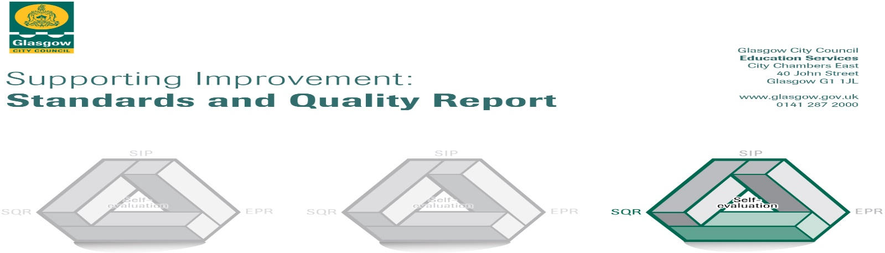

The summary report is provided for parents/careers and partners to outline our achievements this session and our priorities for next session. Throughout this session we have taken forward our priorities as detailed in our school improvement plan. Through our processes of self-evaluation, we have identified how we can improve outcomes for our children and young people.

Our achievements and improvements this year.
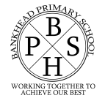
Bankhead Primary
‘Working together to Achieve our Best’

In Bankhead Primary, we are very proud of our school. Our school provides a happy and nurturing environment where learners can grow and develop. Our learner quotes provide a flavour of our school environment.
‘We never give up.’

‘We have kind students’

‘I have a nice teacher.’

‘We are always working hard.’

Our values of safe, respect and ready are at the heart of all we do. Our school visions. Developed in session 2022/23 is, ‘To nurture secure and respectful individuals with lifelong aspirations.’

In the document which follows, we will provide an insight into our main achievements from session 2022/23

Leadership of change
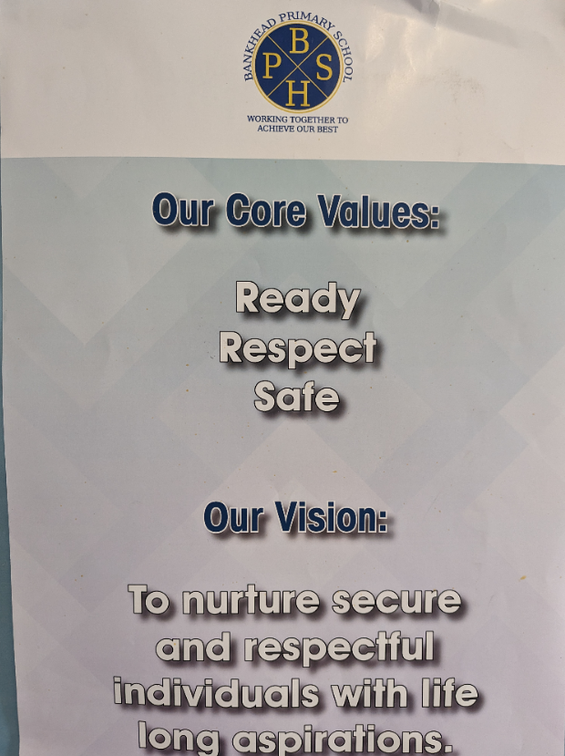
This year, as part of our improvement plan we consulted parents, pupils and staff on the development of our school vision. This vision will be used to underpin the work of the school in the year ahead and will be the driving force shaping the direction of our school.

In session 2022/23 two members of staff were trained in Drawing and Talking, allowing us to extend our reach in supporting vulnerable learners. Six members of staff were trained in Catch Up Literacy, allowing us to begin taking this targeted intervention forward. Our Support for Learning team were trained in Makaton, allowing us to support pupils in communicating. Our staff team have continued with Classroom Culture training and have shown commitment in taking this forward within their classrooms and within the wider school context.

Learning, teaching and assessment
This year, staff have undergone refresher spelling and phonics training and have also undertaken Active Literacy reading training to support them in delivering active literacy strategies consistently across the school. Our active literacy coordinator has developed planners and resources to support implementation and has carried out observations. Reading training has increased staff knowledge of the main techniques, strategies and approaches used in active literacy reading.

I know the main techniques, strategies and approaches to be used in the delivery of active literacy reading.
Baseline – February 2023 | Follow Up - August 2023
16% | 100%

Staff evaluations suggest next steps will be to develop consistent approaches to assessment in phonics and spelling. In reading staff would benefit from miscue analysis and running record training.

Staff have continued to develop their understanding of effective data use at in service and staff meetings. I May 2023, we explored whole school standardised data, with particular focus on highly able learners and less experienced learners. Following the session, staff reported the following:
Staff ‘Bag Its’
Data Session May 2023
- Useful to see data across the school. Would like to do the same with just my class.
- How to view/discuss data. Making a graph for my class.
- Very helpful to hear staff across all levels discussing data.
- Data – v useful. Comparisons of pupil voice v interesting
- Really useful to explore issues around more able and less able pupils
- Looking at data and where to target
- I now feel excited about data
- To look at data, able to compare it to last year. Good to see progress of lack thereof
- Really beneficial to read pupils views about their learning.
- Found this really interesting and good ideas were discussed. I also thought it was important to see what the children had to say.

Ensuring wellbeing, equity and inclusion
This year, our Rights Respecting School Committee achieved their Bronze level status and are now continuing their journey to achieve silver. The promotion of children’s rights is achieved through the development of classroom charters and children’s rights are promoted through assemblies. Our classroom culture co-ordinator has promoted classroom routines and each class has a routine which has been shared. In session 2022/23, we introduced the VIP Tea as a way of recognising pupils who have gone above and beyond, this is linked with pupils achieving a positive note or phone call home, and a ‘We Value You’ nomination from their peers. All classes have introduced recognition boards. Our ASN coordinator has worked to revamp our additional needs calendar and has developed materials to ensure consistent approaches in supporting learners with additional support needs.

Raising attainment and achievement
All pupils participated in the Hi5 award this session.
This session we celebrated the King’s Coronation. Pupils participated in a tea party as well as a range of activities. Three of our pupils worked together to submit an entry to the Glasgow City Council poetry competition as part of the celebrations for the King’s Coronation and won the competition.

This session we revamped our P1 induction. Pupils were invited to the following events;
February Family Fiesta
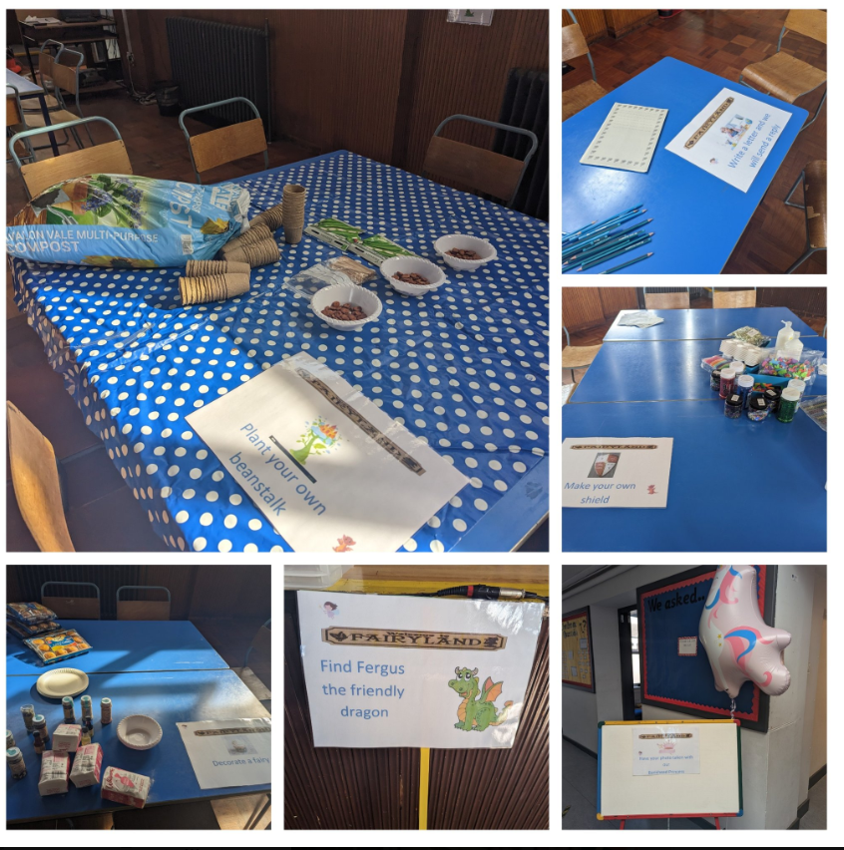
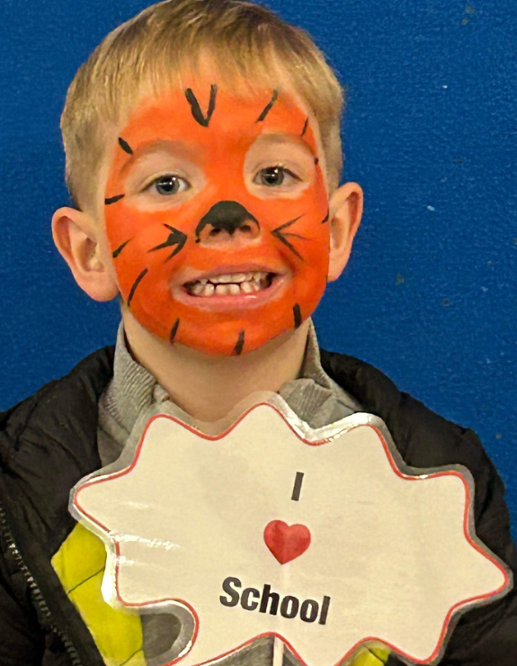
This informal evening event provided an opportunity to take part in a range of activities such as animal handling; cake making, photo booth, face painting and guided tours led by House Captains.

Awesome April
Children were invited to another informal evening event during which they designed shields, met a magical Princess, beanstalk planting and had story telling sessions delivered by a magical dragon.

P1 Story Trail
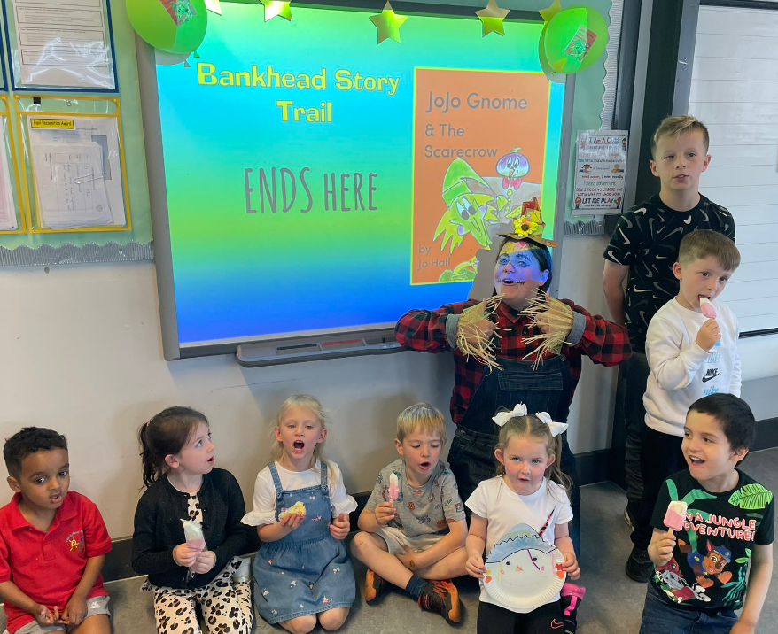
Children and their families took part in a story trail. This event was an afternoon event whereby P1 pupils were invited to walk around the local community to look for clues and read parts of a story. They then visited Knightswood library where they met Sally the Scarecrow. The trail ended back at school where children took part in activities such as singing, cake decorating and arts and crafts.

In addition to formal inductions, and the events described above, children with additional support needs were offered additional enhanced transition visits.

Family Learning
We have started to reengage families post-Covid by running a range of family learning events. These include; Everywhere Bear P1 transition project; P1-3 Family Book Club; P1-3 and Play A Long maths sessions.

Sample Comments

Book Club
“Was fun for us and the kids. Very interactive. Enjoyed doing the crafts with the kids and helping then with their reading.”
“Pizza, Story Telling, interaction, activity: Overall 10/10”
“I loved book club. It was super!”

Play a Long Maths
“It was great to see the children sharing and taking turns.”
“It was good, got the children thinking.”
“The girls enjoyed the game, took them a little while to figure out when to subtract.”
We had World Book Day

Promoting Reading
During Summer, we worked in partnership with the local library to run Book Stop sessions. Each Tuesday members of our staff team visited the library to encourage children to participate in the Summer Reading Challenge. This was well attended each week.
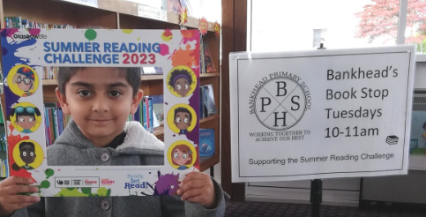

This year, we began working on revamping our school library. Our pupils took part in a range of World Book Day activities. We also established a Reading Ambassadors pupil group to promote reading culture across the school.
Feedback from Reading Ambassadors – What have you learned from being part of this group?
To read more
To read more and get younger children to read.
To read more and read together
Not everyone likes the same books
I’ve learned that reading is very important and it’s really fun.

This year, our EAL teacher set up a Young Interpreters group. The group assisted a variety of pupils and created a video about their work which has been shared.

Feedback from Young Interpreters
I helped this kid O, he was struggling with animals and colours and was struggling with his book a lot, so I helped him.
It’s good knowing that you can help people learn stuff.
It makes you feel like a good person.

Extra-Curricular
This year our children have enjoyed a range of opportunities. After school sports clubs such as football, rugby and multi-sports allowed pupils to be active. We also offered lunch clubs such as table tennis and rugby. Our pupils participated in sports hall athletics and attended a local rugby festival. Our children had the opportunity to go on a variety of trips to support learning such as; Science Centre; Pollok Park and Burrell Collection; Benedetti music sessions. Our P7s enjoyed a successful residential at Lochgoilhead. Participating in a range of activities such as; gorge walking, cycling and climbing. This provided an opportunity to learn team working skills, communication and personal care skills in a real world setting beyond the classroom.

Here is what we plan to improve next year.
- Attainment in Writing: Introduction of Talk for Writing
- Achieve Silver Reading Award
- Achieve Silver Rights Respecting Schools Award
- Improve Attendance and Timekeeping
- Developing our School Curriculum

How can you find out more information about our school?
Please contact us directly if you require further information or if you wish to comment on the report.

The contact e-mail address is: headteacher@bankhead-pri.glasgow.sch.uk

Our telephone number is: 0141 959 3531

Our school address is: 66 Caldwell Avenue, Knightswood, Glasgow, G13 3AS

Further information is available:

Website: http://www.bankhead-pri.glasgow.sch.uk/

Twitter: @BankheadGCC

School App: School App for Parents (available to download for free from Google/Apple app stores)

