Bankhead Primary Remote Learning Charter
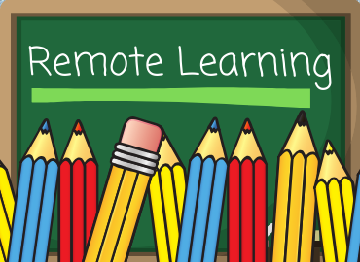
This charter is a set of guidelines to help children, parents/carers, and staff understand the expectations and principles around remote learning.

Guiding Principles of our Home Learning Charter
1. Relationships and Communication
This charter encourages a balance between learning and play, allowing time for family, friends, and relaxing. We want our children to maintain interaction and communication with their teachers and their peers, to continue a sense of belonging to the Bankhead Primary School Community.
2. Consistent Routines
Routine is important. This charter suggests a structure to the week for learners that can be adapted to fit alongside their own family’s schedule and resources (e.g. shared technology, facilities, and other commitments). All learning outcomes, suggested timings and resources will be made explicit enabling pupils and teachers to track progress.
3. Quality over Quantity
This charter outlines an achievable amount of work each day for our learners. This is less than would be expected across a week at school and does not aim to replicate the school day. Explicit instructions from teachers will ensure that learning in this reduced time is focused and essential.
Online Learning
The online platforms in use by Bankhead are Google Classrooms and Microsoft Teams. We will do our best to support families in having access to devices to enable them to engage in online learning.
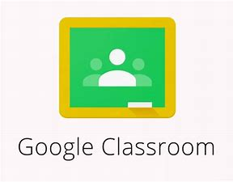
Responsibilities
Teachers are expected to:
- Check in with their class twice a day. Firstly, to welcome them in the morning and give an outline of the plan of work and expectations for the day. Check-ins can be done via a Teams meeting or posting a recorded video or audio message or a paragraph at a specified time on the class channel.
- Post daily literacy and numeracy tasks and signpost any other relevant Health and Wellbeing or other curricular learning e.g.
Literacy and English - daily activities lasting approx. 1 hr
Numeracy and Maths - daily activities lasting approx. 1 hr
Other task (e.g. art, health, science, technology, etc) lasting approx. 1 hr
- Give clear deadlines for all activities posted and archive the activity when the deadline passes.
- Ensure that remote learning is meaningful and allows all children to develop a range of skills.
- Ensure instructions are clear and allow students a means to ask for clarification.
- Give clear limits of how much should be done and expected standards and timings for tasks.
- At second level, help learners to break up longer pieces of remote learning into smaller parts.
- Be specific about where to find resources and provide direct links where possible.
- Monitor who is engaging with Google classrooms in terms of submitted tasks, etc. This is to see if we can help or support children to access their learning.
- Not set remote learning to be completed during holidays.
- Not set tasks for children who are unwell.
Learners are expected to:
- Check their Google Classroom profile for work posted each day by their teacher.
- Ensure they understand the remote learning tasks i.e. success criteria and deadlines and that they ask for help or assistance directly from their teacher when necessary.
- Follow the weekly timetable to help organise learning for the day and complete assigned tasks on time.
Parents, Carers and Families can help to:
- Work in partnership with the school to support access to a digital device.
- Provide an appropriate environment for home learning e.g. a comfortable workspace and blocks of uninterrupted time that help support learning. Parents do not need to replicate the classroom at home.
- Give some support especially to children working in Early to First Level, P1 to P4, to engage in tasks and communicate with their teacher.
- Promote a healthy balance between remote learning and family time.
- Provide encouragement and appropriate support without doing the home learning for their child. Help to motivate and coach children in time management and self-organisation skills when needed. Encourage positive self-talk and staying connected with others.
- Stop their child from continuing to engage in remote learning for extended periods of time, even if it is not complete. It is important to ensure a balance of rest periods and family and social time to support wellbeing.
- Encourage remote learning to be undertaken, where possible, in the typical hours of a school day. We appreciate there may need to be some flexibility, especially where resources are shared as a family.
- Let the school know if your child is reluctant to engage or if you need additional resources.
We understand that (most) parents are not teachers so we will provide as much support as we can. Parents can encourage their children to ask questions via Google classroom if support is required and parents should contact teachers through Google classrooms private messaging. It is important to remember that teachers will also be taking regular breaks away from the computer and may also be supporting their own children and families.
Effective Communication
Our main platform for communicating with our families is through our school website:
http://www.bankhead-pri.glasgow.sch.uk/
Please check regularly for updates. We would also like to communicate through Group Call email messages. Group call will enable us to save money but will only work if we have email addresses for our families. To provide us with a current email address please send an email with you child/children’s name and class to:
gw10rutherfordirene@glow.ea.glasgow.sch.uk
You will also need to download the Groupcall Xpressions App to receive these messages.
Text alerts will only be used in exceptional circumstances.
Any parent wishing to contact the school can do so by calling the school office between 9am and 3pm
Head Teacher: Mrs Celine McKinlay
66 Caldwell Avenue
Glasgow
G13 3AS
headteacher@bankhead-pri.glasgow.sch.uk
0141 959 3531

