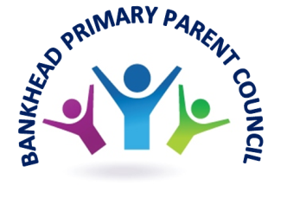
Dear Parents

Your opinion
At the recent Parent’s Night consultation we gathered the following from you:
- the majority of you agreed that the we ask your views on how the school is run and fundraise for the school
- almost half of you agree that the PC helps to develop the school improvement plan
- however, we need to do more consultation with you about how you feel about your child’s learning and your views of the school
- the issues you would like us to bring up with the school are bullying and after school clubs
- almost all of you get information about what we are doing from the school newsletter, school bag drop or the Xpressions App
- the majority of you do not know about the PC website
- the majority of you would consider getting more involved in the school
- the majority of you are satisfied with the new weekly email update, although the remainder do not know about the update
We aim to contact those of you who gave us your contact details directly to confirm how you can help.
We aim to consult with you again at Parents Night in May on how you feel about the teaching and learning in the school.

WE ARE STILL COLLECTING RESPONSES TO THE SURVEY – IT IS AVAILABLE AT - https://forms.gle/VWxJT4n8BVwfQP1e9
Car free zone

REMEMBER THERE IS A NO CAR ZONE AROUND THE SCHOOL IN THE MORNING AND AFTERNOON:
- from 8:30am – 9:15am
- from 2:30pm – 3:15pm

Road safety
We would like to say a HUGE thank you to the P5-P7 road safety committee whose hard work has paid off – we now have a new Lollipop person where Polnoon Avenue meets Holehouse Drive.
Fundraising
Since our last newsletter we have held our first ever Themed Family Quiz night!
We would like to say a HUGE congratulations to all our teams. It was an amazing night and really good fun as shown by the buzz and laughter in the room!! AND, we made a total of £228 towards our school trips! We have been so encouraged that we aim to hold one again next February ….
We still have a long way to reach our target so let’s keep going!
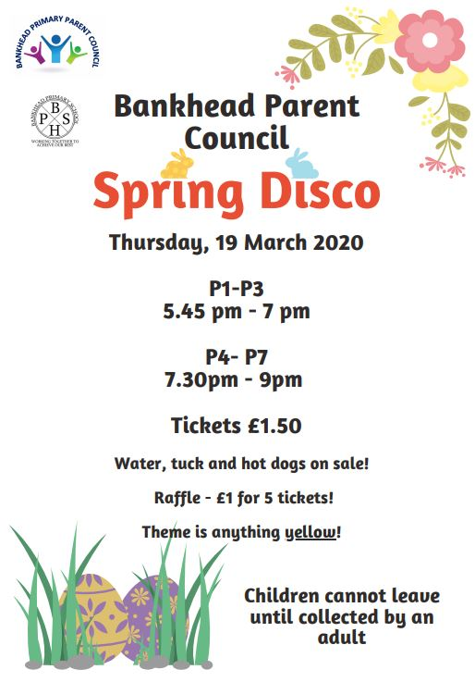
Talking of fundraising – we would like to remind you about the Spring Disco on Thursday 19 March – this year we are introducing a colour theme – all children are encouraged to wear something YELLOW … a hair bauble or a pair of socks is enough!

Tickets will be on sale from Thursday 05 March at the school office.

As usual, we will require parents to help at the disco.
If you can help then please leave your details by:
- email bankheadparentcouncilgcc@gmail.com
- or, using the form below with your details and return to the school office
- or, phone the school office and leave your details.
We will contact you if you are required.

Parent’s name:
Phone number:
I would like to help at P1-P3 disco at 5.45pm - 7pm
I would like to help at P4-P7 disco at 7.30pm - 9pm

Parent News
Scottish Government is consulting on the Parental Involvement Act at present. We would encourage you to complete the questionnaire at https://consult.gov.scot/learning-directorate/parental-involvement-act/.
Closer to home … every Monday Knightswood Library offer friendly Assistance with Universal Credit sessions. Please phone 0808 169 9901 to make an appointment.
Finally, remember to check out the events at Knightswood Community Centre at https://www.knightswoodcentre.co.uk/events/.
We would like to remind you to visit our website, which we keep regularly updated with information about what is going on locally and nationally for parents, with useful websites and information to help you with your child’s learning at home.
PC website at - https://sites.google.com/view/bankheadgccparents/home

Upcoming meetings
We would like to invite all parents to our next meetings on Mondays on 30 March, 04 May and 01 June at 6:30pm. Our AGM will take place on Monday 01 June before our normal meeting.

If you wish to attend please email bankheadparentcouncilgcc@gmail.com and we will be in touch with the venue.

The Agenda for the upcoming meeting is available on our website https://sites.google.com/view/bankheadgccparents/home

Remember to check the notice board by the main door for all our latest communications.

From your Parent Council

