From Dunkirk to America joining the war
On 27th May 1940, 300,000 troops were rescued from the beaches of Dunkirk by soldiers, sailors and everyday people and taken back to England. This was known as the Dunkirk evacuation. Whilst it was a military withdrawal (some would say retreat), it enabled Britain to retain some of her fighting strength. Britain was now awaiting her next trial; Britain was awaiting invasion.
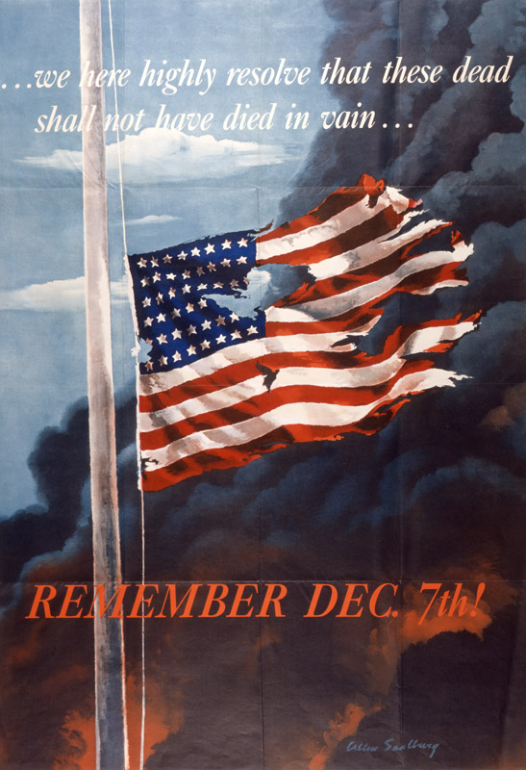
Operation Sealion was the German plan to invade and take over Britain. It planned for thousands of paratroopers and soldiers to be shipped/dropped into Britain to take over London and therefore the government. Hitler started to assemble a vast armada with which to destroy Britain’s defences. Germany had already started bombing British cities (The Blitz) and Britain’s pilots were engaged in the Battle of Britain (Spitfires fighting Me109s above South-East England). Operation Sealion was never actually given the go-head – there are many reasons as to why it was called off: Britain could still control her skies, The Royal Navy had a formidable array of ships and Germany struggled to gather the equipment necessary. Hitler’s greed, however, also spared Britain the invasion. Hitler wished to attack and destroy The Soviet Union (Modern-day Russia). On 22nd June 1941 Germany invaded Stalin’s Russia – putting Operation Sealion onto hold permanently.
Whilst Britain was still struggling with the German bombing raids and Russia and Germany were fighting bitter, enormous battles to the East, The United States was debating whether or not to help Britain. The Americans despised the Nazis (as the Nazis were opposed to freedom), and wished to intervene. However, The USA had more pressing problems closer to home. Japan had been showing many signs of aggression in The Pacific, killing millions of Chinese people and threatening many of the islands of The Pacific. America had stopped countries trading important supplies with the Japanese which had angered the Japanese government. Sensing that America would stop their future wars Japan did the unthinkable, they assembled a naval fleet (complete with aircraft-carriers) and set out for Pearl Harbour. On the morning of 7th December 1941, Japan launched a surprise attack against America ships in The Pacific inflicting enormous damage. Importantly – and the importance of this cannot be understated – America’s own Aircraft-carriers were not in the harbour; they were on manoeuvres many miles away.
On the mainland, the American people were indignant. They could not believe that Japan would launch an unprovoked attack upon them. Instead of wanting to surrender to the Japanese (as the Japanese leaders had hoped), The USA readied itself for destroying Japanese military power and set its goal at bringing peace and freedom to The Pacific.
America did still not have a strong reason to declare war on Germany (and hope to restore freedom to the French, Dutch, Flemish, Norwegian and Danish people). In one of those strange quirks of war, America did not have to worry. Hitler – his confidence at an all-time high – declared war on America. Britain and America now stood together against tyranny.

From Dunkirk to America joining the war
- How many troops were rescued from the beaches of Dunkirk?
- How did the Dunkirk evacuation help Britain?
- What was Operation Sealion?
- Name two planes which fought in the Battle of Britain.
- When did Germany invade Russia?
- Copy a phrase which shows that Japan had been evil in the pacific.
- What word shows the America was not expecting the attack at Pearl Harbour?
- What word in the paragraph starting: On the Mainland shows that the America people were angry?
- Explain how America ended up at war with Germany (2)
- How do you think Britain felt when America was at war with Germany. Give evidence from your text to support your answer (2)
- The text talks about Hitler’s greed. How does the text show that Hitler was greedy? (2)
- How do you think the British felt after Hitler invaded Russia?
- Using evidence from the text show how this was a world war. (3)
- Create your own two marker question

