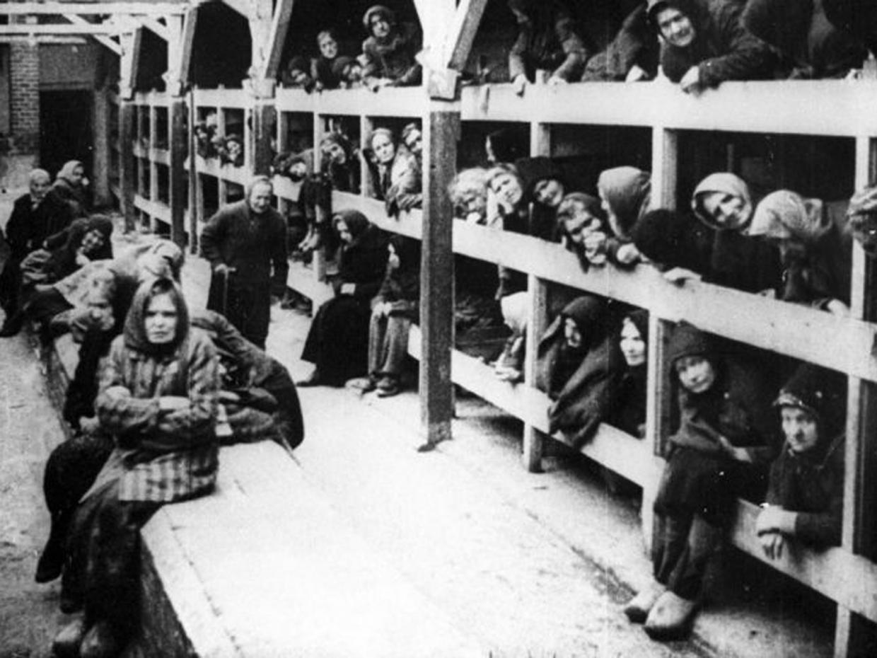
Introduction to the Holocaust

The Holocaust was the systematic, bureaucratic, state-sponsored persecution and murder of six million Jews by the Nazi regime and its collaborators. Holocaust is a word of Greek origin meaning "sacrifice by fire." The Nazis, who came to power in Germany in January 1933, believed that Germans were "racially superior" and that the Jews, deemed "inferior," were an alien threat to the so-called German racial community.
During the era of the Holocaust, German authorities also targeted other groups because of their perceived "racial inferiority": Roma (Gypsies), the disabled, and some of the Slavic peoples (Poles, Russians, and others). Other groups were persecuted on political, ideological, and behavioural grounds, among them Communists, Socialists, Jehovah's Witnesses, and homosexuals.
WHAT WAS THE HOLOCAUST?
In 1933, the Jewish population of Europe stood at over nine million. Most European Jews lived in countries that Nazi Germany would occupy or influence during World War II. By 1945, the Germans and their collaborators killed nearly two out of every three European Jews as part of the "Final Solution," the Nazi policy to murder the Jews of Europe.
Although Jews, whom the Nazis deemed a priority danger to Germany, were the primary victims of Nazi racism, other victims included some 200,000 Roma (Gypsies). At least 200,000 mentally or physically disabled patients, mainly Germans, living in institutional settings, were murdered in the so-called Euthanasia Program.
As Nazi tyranny spread across Europe, the Germans and their collaborators persecuted and murdered millions of other people. Between two and three million Soviet prisoners of war were murdered or died of starvation, disease, neglect, or maltreatment. The Germans targeted the non-Jewish Polish intelligentsia for killing, and deported millions of Polish and Soviet civilians for forced labour in Germany or in occupied Poland, where these individuals worked and often died under deplorable conditions.
From the earliest years of the Nazi regime, German authorities persecuted homosexuals and others whose behaviour did not match prescribed social norms. German police officials targeted thousands of political opponents (including Communists, Socialists, and trade unionists) and religious dissidents (such as Jehovah's Witnesses). Many of these individuals died as a result of incarceration and maltreatment.

- What was the Holocaust?
- How many Jews were killed in the Holocaust?
- What does the word Holocaust mean?
- What word in the first paragraph shows that the Nazis thought they were better than others?
- Name four other groups of people who were targeted by the Nazis.
- What was the Jewish population of Europe in 1933?
- What fraction of Jews were killed in Europe by 1945?
- Look at the paragraph beginning Although Jews…
  - What was the Euthanasia Program?
- How has the author used language to show that the Nazis were evil? (2)
- What do you think life would have been like for a Jew in German-occupied Europe? Use evidence from the text for your answer. (3)
- How to you think the Americans and British felt when they defeated Germany and found the death camps?
  - Use evidence from the text for your answer. (4)

