From the declaration of war to the Blitz
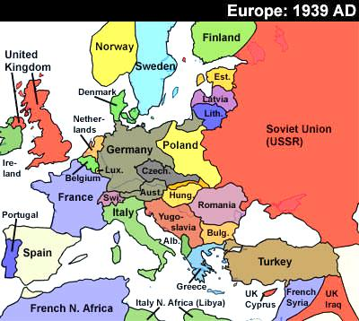
After Hitler had invaded Poland, Poland put up a valiant defence, but was ultimately defeated by Germany on 27th September 1939. On the 29th Poland is divided up between the Soviet Union and Germany. Britain and France await Hitler’s next move.
Nothing happens that winter and Britain rushes troops to France in anticipation of Hitler’s next attack: The West. This period of war without any fighting is known in Britain as The Phoney War. Then, on April 9th Germany invades Denmark and Norway – defeating them easily (the British troops in Norway are evacuated). It is clear now that Hitler can only be stopped by force and British and French troops try to anticipate Hitler’s next move. On May 10th, history is sealed, as Germany rushes through Belguim, Luxembourg and Holland (Holland surrenders on May 15th; Belgium surrenders on May 28th). German troops spill into France and overwhelm the allied forces there. Britain has no choice but to evacuate at Dunkirk (May 26th). 300,000 troops are salvaged from the beaches at Dunkirk (Northern France) and are taken back to Britain to fight another day.
Just as France is about to surrender to Germany, another bombshell is dropped: Italy declares war on Britain and France. Italy’s leader: Mussolini, thinks that Britain and France are in a weak state and could use this opportunity to take land from them. France, with German troops sweeping through Paris and most of the strategic areas have no choice but to surrender. On 22nd June 1940, France surrenders to Germany leaving Britain alone against German aggression in Europe.
As soon as war was declared, planes from Germany and Britain had been duelling in the skies above Europe. The planes were evenly matched and great skill was shown by pilots on both sides. As soon as France fell, Britain had to fight Germany in the skies alone. Germany initially wanted to destroy British airfields, but, after some navigation errors, actually started to bomb London and other cities during the night. The Blitz had begun. The Blitz would claim the lives of 32,000 British people (enough to fill a football stadium). 60% of these casualties were in London.
It was during the Blitz that the Moonlight sonata raid occurred over Coventry (14th November) which killed hundreds of people and destroyed much of the city (including the beautiful cathedral).

