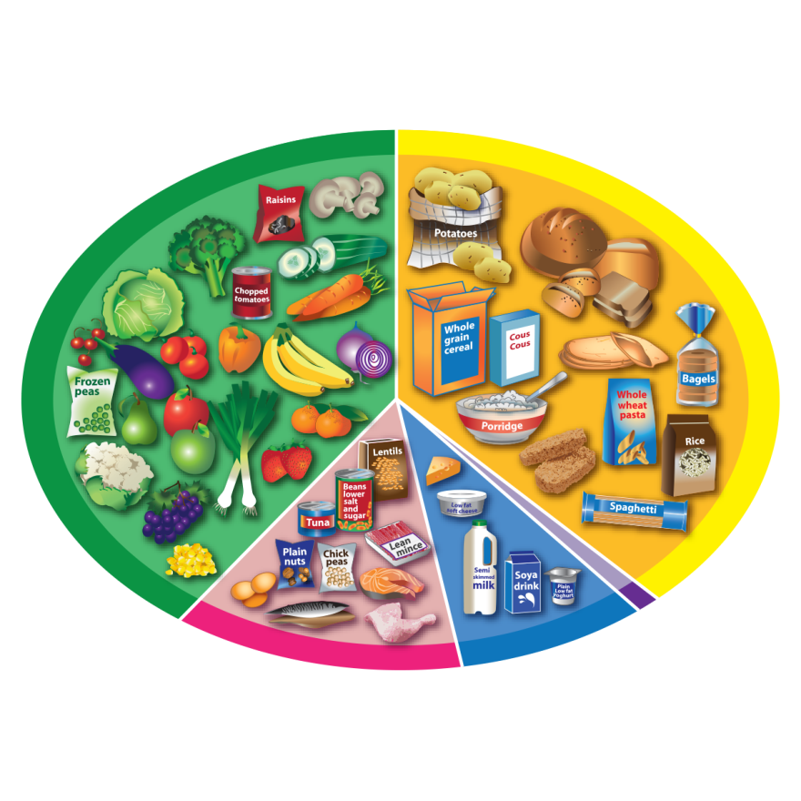
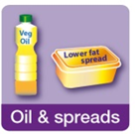
Eatwell guide – plant or animal?

Look at the main food groups on the Eatwell Guide.

Give examples of food from a plant and/or an animal for each group.

Fruit and Vegetables
Carbohydrates
Potatoes, bread, rice, pasta
Name:
Date:

 | Plant | Animal
Fruit and vegetables

Potatoes, bread, rice, pasta …

Beans, fish, eggs, meat …
Dairy and alternatives

Oil and spreads

Dairy and alternatives
Protein: fish, meat, beans, eggs

