Glasgow Libraries Digital Books Help – May 2020.

How to borrow digital books through your Glasgow Libraries membership.
∗ If you don’t have your library membership number or can’t remember your pin number you can sign up online for a new account here: https://libcat.csglasgow.org/web/arena/joinlogin

You will need:
- Your library membership number (it is above the barcode on your library card, type it with no spaces between digits) and your PIN code/password (this is your date of birth in the DDMMYYYY format) – these are your sign in details;

- A tablet/smartphone/computer with internet access.

Glasgow Libraries’ online library can be found:
- for computers, on OverDrive (https://libcat.csglasgow.org/web/arena/ebooks)

- for phones, on the Libby app which you can
download on Google Play/App Store.

If using the Libby app
Download the app to your phone/tablet and follow the
instructions to log in.

This video tutorial can help you step by step: https://www.youtube.com/watch?v=nC7DYxjtZ4w
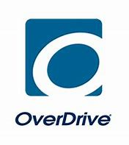
If using Overdrive
- https://glasgow.overdrive.com/
or
- https://glasgow.overdrive.com/library/kids
Sign in from the top right button on the screen.
Now you use the Search bar on top to find a book/author.
Ebooks have a small book icon under them.
Audiobooks have a small earphones icon. 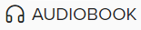
EBOOKS
When you have found a book, click BORROW to take it out on loan;
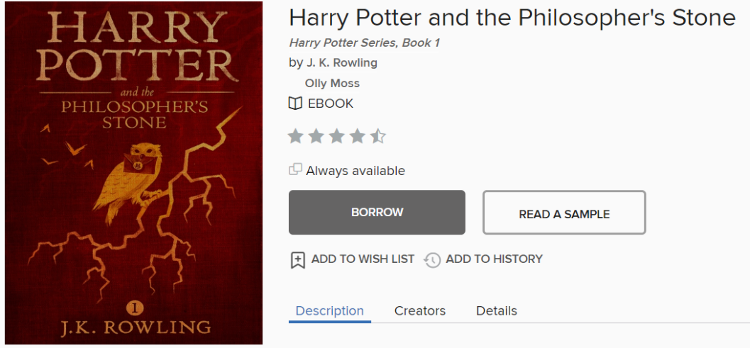
then, select “Read now in browser”:
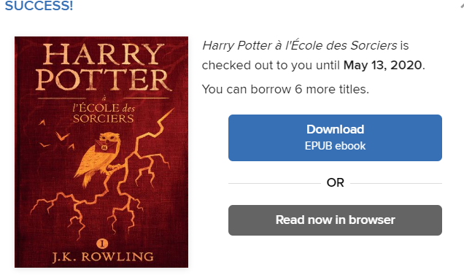
The ebook will open in a new tab/window and you will just have to drag with your mouse to turn the pages; or you can use the arrow keys on your keyboard as well.
♣ Helpful tip! Click on any ebook page, you see three lines at the top right: click them to see the book chapters, or make your ebook dyslexia friendly via the Reading Settings option: select a dyslexia friendly font, change the page background colour, increase font size.

AUDIOBOOKS - Just like with ebooks, click Borrow and then choose “Listen now in browser”. The audiobook will open in a new tab and will look like this:
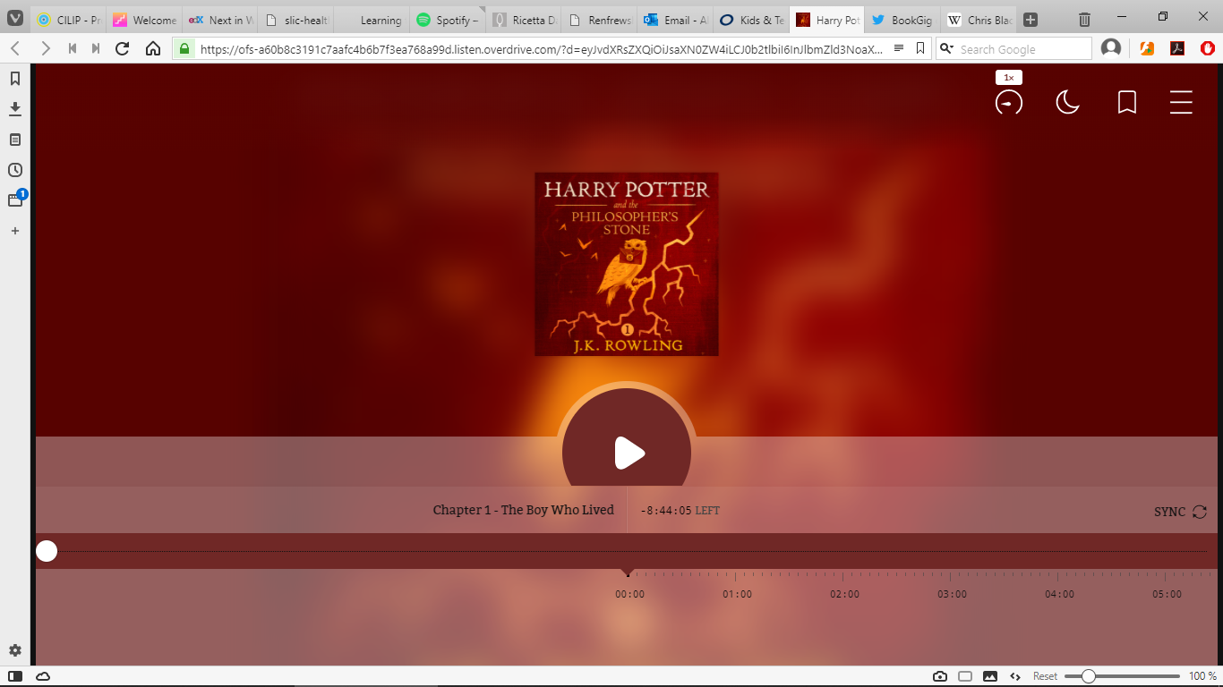
♣ Helpful tip! Click on the chronometer symbol on the right in order to speed up or slow down the reading speed so it’s easier to listen to. The three lines on the right, just like on ebooks, will give you access to the various chapters of the book.

Returning loans:
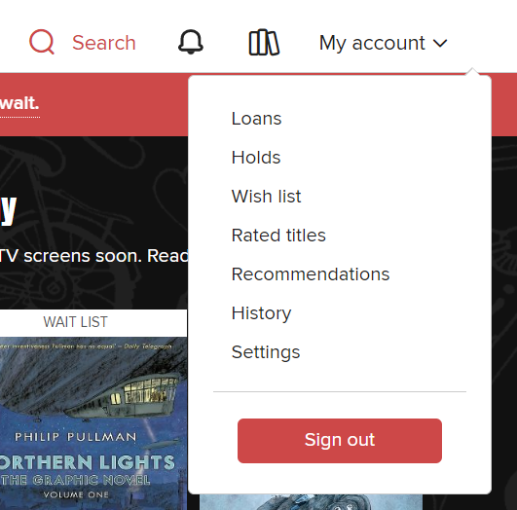
You can then access your loans day after day from Your Account > Loans. From here, you will also be able to return your book, or renew it.

Enjoy your digital books! 😊

